

**Sales Management**

**Corporate CRM**

**Solution Approach Document**

**V 1.4**

**Version 3.0**



**Sales management**

CORPORATE crm

Solution approach document

**v 1.4**

By

Acidaes Solutions Pvt. Ltd.

Infospace, Tower 1, Ground Floor, Block B, Plot No. 2,

Sector 62, NOIDA - 201 309, UP, India;

Tel: (+91) 120 6784333; Fax: (+91) 120 6784334

Confidential and Proprietary

©Copyright 2011-2016, Acidaes Solutions Pvt. Ltd.

All Rights Reserved.

*The management team of Acidaes (the Company) has prepared this business document, and is being furnished to selected individuals within The Bank for the sole purpose of proposal evaluation, for sale of CRMNEXT and CRMNEXT services. This business document is confidential, and contains ideas, concepts, processes and other information that the Company considers proprietary. Readers are to treat the information contained herein as confidential and may not disseminate, copy or reproduce it in any form without the expressed written permission of the Company. ‘Acidaes’, ‘CRMNEXT, ‘Simplifying Technology’ and ‘smart.easy.complete’ is applied trademarks of Acidaes Solutions Pvt. Ltd. All other trademarks are the property of their respective owners.*

**Revision History**

|  |  |  |  |  |  |
| --- | --- | --- | --- | --- | --- |
| **Sr. No.** | **Date** | **Version** | **Description** | **Author** | **Reviewer** |
| 1 | 02-04-2018 | 1.0 | Document created | Mainakh |  |
| 2 | 23-04-2018 | 1.1 | Document Modified | Mainakh |  |
| 3 | 24-04-2018 | 1.2 | Reviewed the document | Mainakh | Imtiyaz A Kitekar |
| 4 | 21-05-2018 | 1.3 | Document Modified | Mainakh | Kishen Paresh Madhvani |
| 5 | 26-05-2018 | 1.4 | Document Modified as per I&M Feedback | Mainakh |  |

**Table of Contents**

1. Introduction 5

1.1 Abbreviations 5

1.2 Objective 6

1.3 Scope of the Document 7

2. Process Setup 9

2.1 Roles 9

2.2 Product Management 13

3. Prospecting Process 15

3.1 ASIS process of Deal Management through Account Planning and SFE Tool 15

3.2 Proposed Prospecting Process 15

4. Deal Process 21

4.1 Customer/Prospect Search 21

4.2 Milestone & Status (Stages and Sub Stages) 27

4.3 Product Bundling Logic 27

4.4 Deal Sources 28

4.5 Deal Process Description 28

5. Client Coverage Profile & Meeting History 44

5.1 Activities (Tasks & Appointments) 44

6. Assignment Logic 49

7. Escalation Matrix 50

8. Alerts Matrix 50

9. Views 51

10. Budgeting, Account Planning and Achievements 52

10.1 ASIS Process 52

10.2 Proposed Processes 53

11. IDR Session Points 58

12. Assumptions 73

# Introduction

This is an approach document for implementing I&M Bank’s Sales process comprising of Deal process using CRMNEXT for the segments such as Corporate & Institutional Banking and Business Banking.

## Abbreviations

Please find the list of abbreviations used in the document below:

|  |  |  |
| --- | --- | --- |
| **Sr. No.** | **Abbreviation** | **Description** |
|  | CIB | Corporate & Institutional Banking |
|  | BBD | Business Banking Department |
|  | BM | Corporate Branch Managers |
|  | IRM | Institutional Relationship Managers |
|  | RA | Relationship Analyst |
|  | RM | Relationship Manager |
|  | FI | Financial Institutions |
|  | CBS | Core Banking System |
|  | Fin | Finacle |
|  | LOS | Loan Originating System |
|  | SFE | Sales Force Effectiveness Tool |
|  | ETB | Existing To Bank |
|  | NTB | New To Bank |
|  | CIF | Customer Information File – number uniquely identifying customer in Core Banking and LOS |
|  | Customer Id | Customer Identifier for identifying customer uniquely in SFE tool |
|  | FTP | Fund transfer Pricing |
|  | CFY | Current financial year |
|  | PH Reps | Product House representatives |
|  | Bank CRM | Customer Relationship Management tool to be implemented in I&M bank powered by CRMNEXT. |
|  | T-1 | Previous Business day |
|  | CIB-Head | Corporate & Institutional Banking Head |
|  | CIB–BM | Corporate & Institutional Banking – 4 Branch Managers handling some accounts |
|  | PH-Manager | Product House Manager |
|  | PH-Reps | Product House representative |

Table 1-List of Abbreviations

## **Objective**

1. The objective of is to implement the same process for capturing and processing opportunities, deals including Approvals and Account Opening through Core Systems for segments such CIB and BBD.
2. This will ensure Sales life-cycle management for CIB and BBD segments. The CIB and BBD Sales process (Opportunity and Deal) flow will be same.
3. Leads process will be attained through prospect creation whereas opportunity and deal will be attained through same process for Prospect and Customers respectively.
4. The processes will take input of Segment to identify the RMs involved.

## **Scope of the Document**

This document covers the sales processes for Product partner teams and RMs.

The document will cover following in detail:

1. Process Setup
2. Roles
3. Sales Process Flow :
   1. Current - ASIS



* 1. Proposed Sales Process
     1. ETB
        1. Deal Process: Any Upselling/Cross Selling for an existing account will be handled through Deal process.
           1. Various Stages of Deals
           2. Credit Approval

Internal

External

Closure Finacle

* + 1. NTB
       1. Lead Process: Any new Selling for non-existing account will be handled through Lead process at early identification stage of Sell. This will be achieved in “Bank CRM” through Leads. This is explained in detail inside solution approach for Individual Sales Management.
       2. Opportunity Process: Any new Selling for non-existing account at negotiation stage will be handled through prospect creation and Opportunity process through prospect.
          1. Same process flow as that of Deal Process, Including

Fields

Mandatory

Optional

Stages

Views

Integration with Finacle

* + - * 1. The difference with deals process will be, no CIF/Customer Id will be available for NTB Prospects.

1. Deal Process
2. Client Coverage Profile and Meeting History
3. Assignment Logic
4. Escalations
5. Alerts
6. Views
7. Budget allocation
8. Wallet sizing
9. Account Planning
10. Achievement tracking
11. Assumptions

# Process Setup

This section describes the administrative setup for sales process of I&M, taking sample users as example.

## Roles

### Bank Business ASIS Role Hierarchy

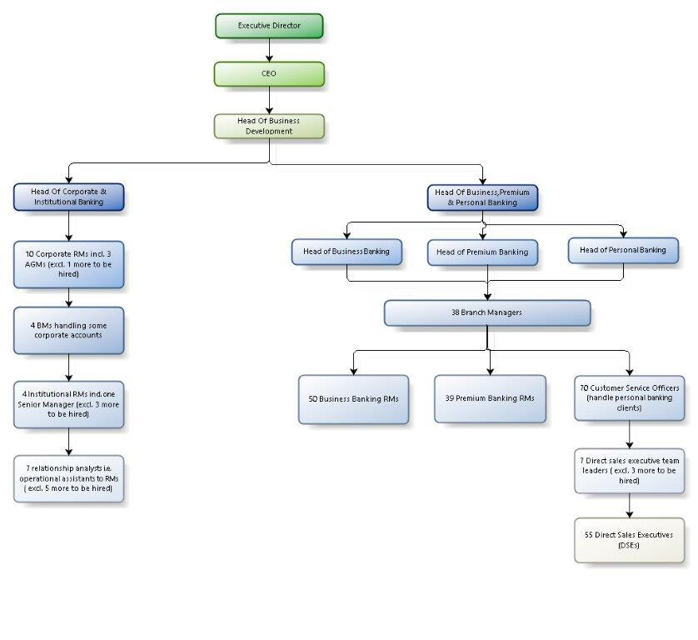

Figure 1 ASIS Bank Business Hierarchy

### Bank ASIS Product House Hierarchy

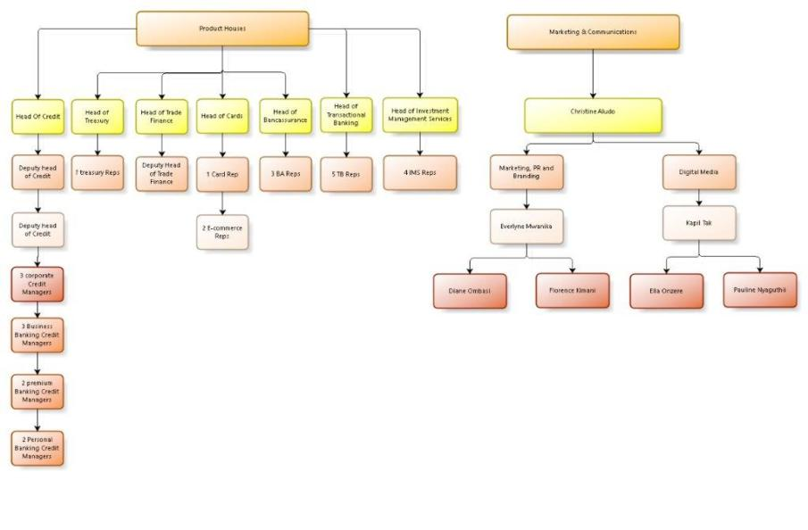

Figure 2 ASIS Bank Product House Hierarchy

### Proposed System Roles for the Sales Process Flow

|  |  |  |  |
| --- | --- | --- | --- |
| **Sr. No.** | **Abbreviation** | **Description** | **Access Rights** |
|  | CIB – RA | Relationship Analyst | 1. **Deal**: View 2. **Customer 360:** View, Modify 3. **Views:** View |
|  | CIB - RM | Corporate Relationship Manager | 1. **Deal**: Create, Modify, View 2. **Prospect /Customer 360**: Create, Modify, View 3. **Views:** View |
|  | CIB – BM | Corporate Branch Managers | 1. Same as “CIB - RM” for existing some accounts. |
|  | CIB-Head | Head of Corporate & Institutional Banking | 1. **Deal**: View 2. **Prospect /Customer 360**: View 3. **Views:** View |
|  | PH-Head (can also be rep) | Product House Head: This role will be common across all product houses. Any approval needed for sales process flow will be routed based on this role and corresponding product. | 1. **Deal**: View, Modify 2. **Prospect /Customer 360**: View 3. **Views:** View |
|  | PH-Reps | Product House Representative: This role will be common across all product houses. Any assignment needed for sales process flow will be routed based on this role and corresponding product. | 1. **Deal**: Modify, View 2. **Prospect /Customer 360**: View 3. **Views:** View |
|  | BB-Head | Business Banking Head | 1. **Deal**: View 2. **Prospect /Customer 360**: View 3. **Views:** View |
|  | BB-RM | Business Banking Relationship Manager | 1. **Deal**: Create, Modify, View, Approve 2. **Prospect /Customer 360**: Create, Modify, View 3. **Views:** View |
|  | BB – BM | Branch Managers | 1. Same as “BB - RM” for existing some accounts. |
|  | Process Champion | All Segments | 1. **Deal**: Create, Modify, View, Approve 2. **Prospect /Customer 360**: Create, Modify, View 3. **Views:** View |

Table 2- Roles

### Proposed Role Hierarchy

1. For Corporate & Institutional Banking group: The proposed CIB sales team hierarchy has been depicted below:

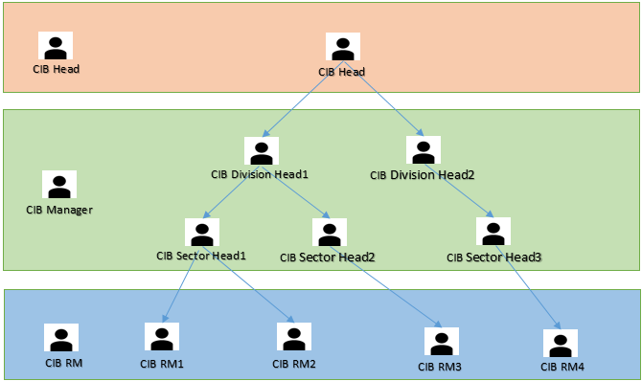

Figure 3 Proposed CRM hierarchy for CIB

Different in Practice

1. For Business Banking Department: The proposed BBD sales team hierarchy has been depicted below:

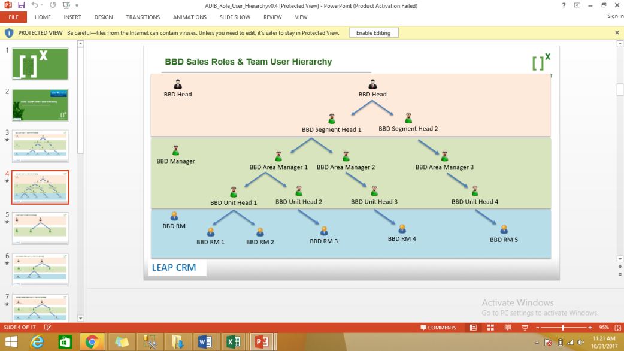

Figure 4 Proposed CRM hierarchy for BB

Different in Practice

## Product Management

### Product Management

1. Below Table provides existing products prevailing in I&M Bank.

|  |  |  |  |  |  |
| --- | --- | --- | --- | --- | --- |
| **Sr. No** | **Product code** | **Business Category** | **Product Category** | **Product type** | **Pipeline Formula** |
|  |  | Assets | Credit | Insurance Premium Financing | Asset Finance/HP |
|  |  | Assets | Credit | Asset Finance/ Hire Purchase | Asset Finance/HP |
|  |  | Assets | Credit | Temporary Overdraft | Delete |
|  |  | Assets | Credit | Term Loan | Same as Term Loan |
|  |  | Assets | Credit | Overdraft | Same as Overdraft |
|  |  | Assets | Credit | Short Term Loan | Delete |
|  |  | Assets | Credit | Bills Discounting | Same as Bills Discounting |
|  |  | NFI | FX | Spot | Same as FX |
|  |  | NFI | FX | Forwards | Same as FX |
|  |  | NFI | FX | Swaps | Same as FX |
|  |  | NFI | Cards | Credit Card | Formula to be shared |
|  |  | NFI | Cards | Prepaid Safari Card | Formula to be shared |
|  |  | NFI | Cards | E-Commerce | Does not have a formula |
|  |  | NFI | Cards | Prepaid Multicurrency Card | Delete |
|  |  | NFI | Cards | Prepaid Travel Card | Delete |
|  |  | Liabilities | Deposits | Business Transaction Account FCY | CASA |
|  |  | Liabilities | Deposits | Business Transaction Account LCY | CASA |
|  |  | Liabilities | Deposits | Call Deposit | Call Deposit |
|  |  | Liabilities | Deposits | Noble Account FCY | CASA |
|  |  | Liabilities | Deposits | Noble Account LCY | CASA |
|  |  | Liabilities | Deposits | Business Transaction Account LCY | CASA |
|  |  | Liabilities | Deposits | Business Transaction Account FCY | CASA |
|  |  | Liabilities | Deposits | Transactional Account | Delete |
|  |  | Liabilities | Deposits | Term Deposit | Term Deposit |
|  |  | Liabilities | Deposits | Custodial Trading Account | CASA |
|  |  | Liabilities | Deposits | Custodian Current Account | CASA |
|  |  | NFI | Deposits | IMS Services | IMS |
|  |  | Trade Finance | Trade Finance | Import Letters of Credit | Bills Discounting |
|  |  | Trade Finance | Trade Finance | Bank Guarantees | BG/SBLC |
|  |  | Trade Finance | Trade Finance | Local Letters of Credit | Bills Discounting |
|  |  | Trade Finance | Trade Finance | Standby Letters of Credit | BG/SBLC |
|  |  | Trade Finance | Trade Finance | Export Negotiation of Bills under LC | 0.25%* Amount |
|  |  | Trade Finance | Trade Finance | Import Bills on Collection | 0.25%* Amount |
|  |  | Trade Finance | Trade Finance | Purchase Of Export Bills | 0.25%* Amount |
|  |  | Trade Finance | Trade Finance | Bill Avalisation/Co-acceptance | BG/SBLC |
|  |  | Trade Finance | Trade Finance | Export LC Advising | Delete |
|  |  | Trade Finance | Trade Finance | Export LC Confirmation | BG/SBLC |
|  |  | Trade Finance | Trade Finance | Export Bills on Collection | Bills Discounting |
|  |  | Insurance | Banc assurance | WIBA | Bancassurance |
|  |  | Insurance | Banc assurance | Theft | Bancassurance |
|  |  | Insurance | Banc assurance | Fire Commercial | Bancassurance |
|  |  | Insurance | Banc assurance | Motor Insurance | Bancassurance |
|  |  | Insurance | Banc assurance | Travel | Bancassurance |
|  |  | Insurance | Banc assurance | Medical | Bancassurance |
|  |  | Insurance | Banc assurance | Miscellaneous | Bancassurance |
|  |  | Insurance | Banc assurance | Insurance | Bancassurance |
|  |  | Insurance | Banc assurance | Package/Combined | Bancassurance |
|  |  | Insurance | Banc assurance | Marine | Bancassurance |
|  |  | Insurance | Banc assurance | Accident | Bancassurance |
|  |  | Insurance | Banc assurance | Life | Bancassurance |
|  |  | Insurance | Banc assurance | Liability | Bancassurance |
|  |  | Insurance | Banc assurance | Agricultural | Bancassurance |
|  |  | Insurance | Banc assurance | Engineering | Bancassurance |
|  |  | Insurance | Banc assurance | Fire Domestic | Bancassurance |
|  |  | Insurance | Banc assurance | Aviation | Bancassurance |

Table 3: Product Table

# Prospecting Process

## ASIS process of Deal Management through Account Planning and SFE Tool

1. ASIS Deal Process {Explained through MOM dated 6th Apr 2017}



1. ASIS Deal Process through Account Planning {Explained through MOM dated 10th Apr 2017}



1. ASIS Account Planning Sheet {Explained through MOM dated 10th Apr 2017}



## Proposed Prospecting Process

1. Prospect Creation & Deal Classification
   1. For NTB Customers
      1. **Prospects**: Prospects will be associated with NTB customers. These will handle newly identified customers before getting into discussion with them.
   2. For ETB Customers
      1. **Deals**: Deals will be opportunities identified for ETB customers.
   3. The Opportunity and Deal process will be kept same for NTB and ETB customers respectively.

### New to Bank (NTB) Prospects:

### New Prospect Creation Process Flow

1. The Prospect creation process will be followed for the prospective new customers identified as possible lead/Prospect.
2. This is the pre stage of negotiation where the prospect is identified internally before approaching the customer to do all preparative work.
3. The channels for prospects will be
   1. Marketing Campaign
   2. Contact Center
   3. Website
   4. Referrals
   5. Advertisement
   6. Social Media
   7. RM Research/Market Research/New Market:
   8. Research is done by the Business RM or the Product Partner (Sales) Teams on potential NTB customers.
   9. Customer is contacted to determine the potential for selling the product.
4. The prospects will be created in “Bank CRM” through following modes
   1. Manual Entry in “Bank CRM”**:**
      1. The prospect will be identified and created by RM.
      2. The prospect will be “owned by” & “assigned” to Self/same RM. Can be assigned to other RMs/CSOs in other segments where applicable i.e. sent as a lead
   2. Manual Import in “Bank CRM”**:**
      1. The prospect will be imported in Bank CRM through CSV upload by RM.
      2. The prospect will be “owned by” & “assigned” to Self/same RM.
   3. Further Processing
      1. The prospect will be assigned to Self/same RM
      2. The prospect will be internally discussed with product house reps and worked upon by RM.
      3. Once agreed to proceed further, the potential customer will be contacted by RM.
         1. Based on inclination from potential customer, opportunity will be created along with “Prospective Customer” where CIF value will not be available.
5. Prospect Assignment Logic
6. Bulk Assignment –
   * 1. The “Assigned To”/ “Process Champion” of prospect using this functionality will assign Single/multiple prospect to other RMs individually/as well as in bulk manner.
        1. The prospect will be available in view to “Assigned To”.
        2. The “Assigned To” can select prospect one by one or all at once using selection box and assign prospect by clicking “Allocate” action button.
        3. The assignment will take place within same segment or other segments if manually assigned.
7. Manual prospect Creation Process
   1. Creator: prospect will be created manually by following roles:
      1. CIB – RM
      2. CIB – BM
      3. BB-RM
      4. BB - BM
      5. Process Champion
   2. Prospect Data entry:
      1. Basic Description: Prospect will be created with basic/mandatory information as part of ‘Quick Data Entry’, for below products:
         1. Assets
         2. Liabilities
         3. Insurance
         4. Cards
         5. Trade Finance
         6. FX
8. Prospect processing will be stand-alone within “Bank CRM” with no integration with any other system.
   * 1. Prospect Fields

|  |  |  |  |  |  |  |  |  |  |  |
| --- | --- | --- | --- | --- | --- | --- | --- | --- | --- | --- |
| **Sr. No.** | **Field** | **Field Type** | **Comments** | **Field length** | **Field Validation** | **Editable** | **Lookup** | **Dependent on** | **Mandatory** | **Auto** |
|  | **Populate** |
|  | Title | Pick list |  | NA |  | Yes |  | No | Yes |  |
|  | Contact First Name | Alphanumeric |  |  |  | Yes |  | No | No |  |
|  | Contact Last Name | Alphanumeric |  |  |  | Yes |  | No | Yes |  |
|  | Company Name | Alphanumeric |  |  |  | Yes |  | No | Yes |  |
|  | Prospect Owner | Pick list |  |  |  | No |  | No | Yes | Yes |
|  | Account Rating | Pick list |  |  |  | Yes |  | No | Yes | Yes |
|  | Segment | Pick list |  |  |  | Yes |  | No | Yes | No |
|  | Customer Type | Pick list |  |  |  | Yes |  | No | Yes | No |
|  | PIN Number | Alphanumeric |  |  |  | Yes |  | No | No | No |
|  | Company Registration Number | Alphanumeric |  |  |  | Yes |  | No | No | No |
|  | Source | Pick list |  |  |  | Yes | Yes option "Self”, segment values as well | No | Yes | No |
|  | Employee Strength | Pick list |  |  |  | Yes |  | No | No | No |
|  | Industry | Pick list |  |  |  | Yes |  | No | No | No |
|  | Business Sector | Pick list |  |  |  | Yes |  | Dependent on Industry | No | No |
|  | Territory | Picker |  |  |  | No |  | No | Yes | Yes |
|  | Status Code | Alphanumeric |  |  |  | No |  | No | Yes | Yes |
|  | P.O. Box No | Alphanumeric | Unique Criteria for prospect creation |  |  | Yes |  | No | Yes | No |
|  | Postal Code | Alphanumeric |  |  | Yes |  | No | Yes | No |
|  | Address Line 1 | Alphanumeric | Physical Address, Either of Email ID or Mobile Number will be mandatory |  |  | Yes |  | No | Yes | No |
|  | Address Line 2 | Alphanumeric |  |  | Yes |  | No | No | No |
|  | City | Alphanumeric |  |  | Yes |  | No | Yes | No |
|  | State | Pick list |  |  | Yes |  | No | Yes | No |
|  | Country | Pick list |  |  | Yes |  | No | Yes | No |
|  | Mobile | Phone |  |  | Yes |  | No | Yes | No |
|  | Office Phone | Phone |  |  | Yes |  | No | No | No |
|  | Email ID | Email |  |  | Yes |  | No | No | No |

Table 4 List of Prospect Fields

1. **Prospect Creation/Opportunity Process**: This stage marks the creation of a new Prospect for the NTB.
   1. **Prospect Dedupe**:
      1. While creating a new prospect CRM system will check for duplicate records as per defined logic.
      2. Deduplication will occur on the basis of duplicate “Company Registration –Not mandatory Number (P.O.Box & postal code combination)”—Fields will be mandatory.
      3. Field Combinations**:** Either of the condition must be true

| **Reno** | **Rule Name** | **Duplicate record Criteria** | | |
| --- | --- | --- | --- | --- |
| **Parameter** | **Criteria** | **Result** |
|  | Duplicate Prospect | Company Registration No | Same as on existing prospect | Prospect Dedupe screen will appear |

Table 5 - Prospect to Prospect Dedupe

* 1. No CIF will be available for the prospect.
     1. The opportunity creation process will be same as that of deal creation process explained in subsequent sections through Prospect 360.
  2. Below figure shows the sample prospect Layout.

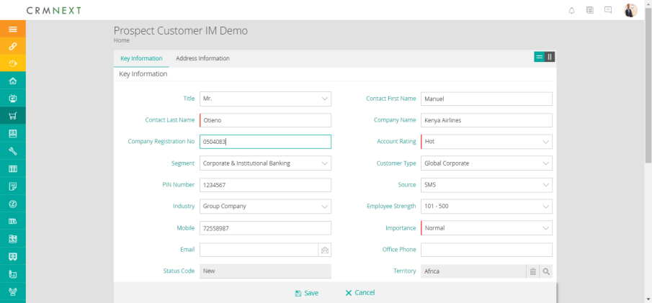

Figure 5-Prospect 360 New/Edit

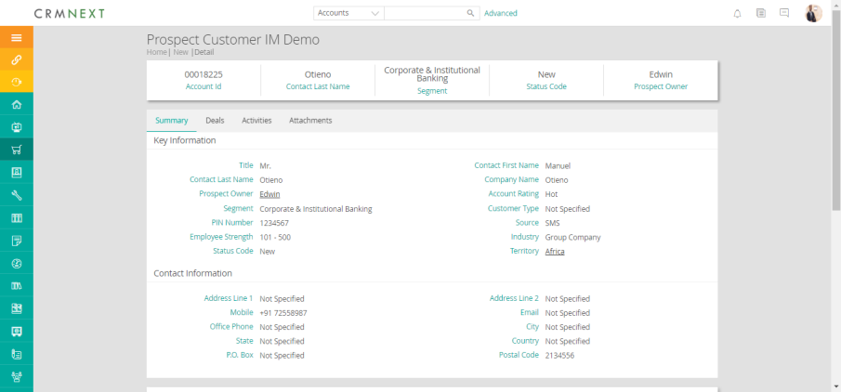

Figure 6 - Prospect Detail Page

# Deal Process

1. The Deal process described below will work for business groups, i.e. CIB & BBD.
2. The process will be used by Business RM of these groups as well as by Product house representatives.
3. These business groups will have same workflow, statuses (sub Stage) and mile-stones (Stages).
4. The process will remain same for NTB and ETB accounts except for NTB prospect will be searched whereas for ETB customer will be searched for the opportunity/Deal creation.

## Customer/Prospect Search

1. RM/Product Partner/rep will search/View the customer/Prospect through following ways.

### Bucket Listing:

1. RM/Product Partner will find the customer using the listing (views) on the summary page.
2. Views are buckets where user will see Prospect/Customer/Task etc. with a few/minimal important fields in form of lists belonging to them & their sub ordinates.
3. Clicking on any of entry will take user to the Card View of the Customer.
4. Following is a screenshot of how RM will see his Customers.

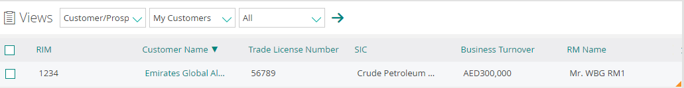

Figure 7: Customer View - RM

1. View works as per scoping such that although the RM will see his record, his manager will see not only see his records but his RMs’ records as well.
2. Below is the screenshot of the manager sees records of RMs under him.

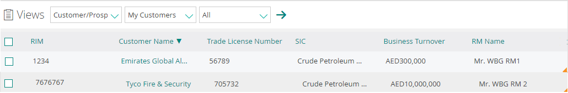

Figure 8: Customer View - RM

### **Search Customer**:

1. Navigation: The user will navigate to the customer screen by clicking on the Customer tab.
   1. Manual Search: "Bank CRM" will provide a "Customer Search" through which the user will perform Customer Search.
      1. Refer the below screenshot for more details:

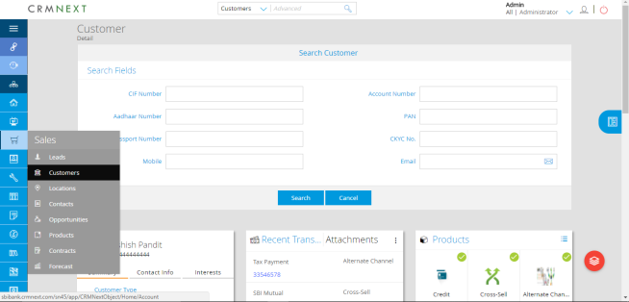

Figure 9: Customer Search

* 1. Accessibility: The search functionality will be provided to all the roles as mentioned under Role & Hierarchy section.
  2. Search Parameters : The below search parameter will be provided with the details as mentioned below:

| **Search Parameter** | **Type** | **Role** | **Search Type** |
| --- | --- | --- | --- |
| Segment | Dropdown | All | Exact |
| Cuts ID/CIF/Prospect Number | Text | All | Exact |
| Mobile Number | Numeric | All | Exact |
| Customer Name | Text | All | Starting with entered Text |
| Account Number | Text | All | Exact |
| Group Name | Text | All | Starting with entered Text |
| P.O. Box Number | Text | All | Exact |
| Postal Code | Text | All | Exact |
| Email | Email | All | Exact |

Table 7 Customer Search Attribute

* 1. Output : There will be 2 possible outcomes based on the search made in “Bank CRM”:
     1. **Outcome 1: Customer Found**:
        1. Based on the below outcome the deal process will be initiated on it.
        2. Refer the screenshot in below mentioned sections for the creation of deal on the outcome.
        3. For this outcome, there will be 2 scenarios.
           1. **Single Customer** –

Screen- When a single /unique customer is found then the application will open on either one of the following:

Prospect 360:

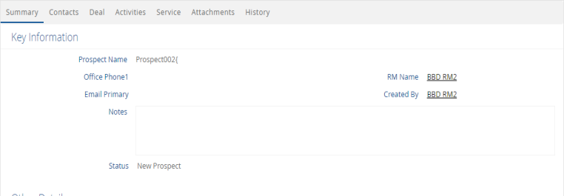

Figure 10- Prospect 360

Customer 360* (refer the screenshot below).

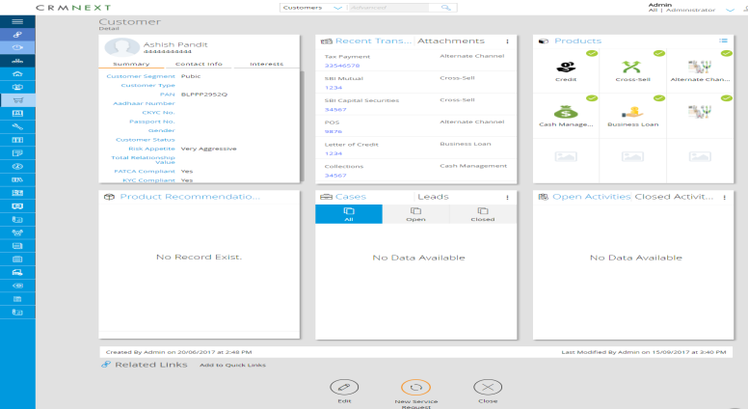

Figure 11: Customer 360

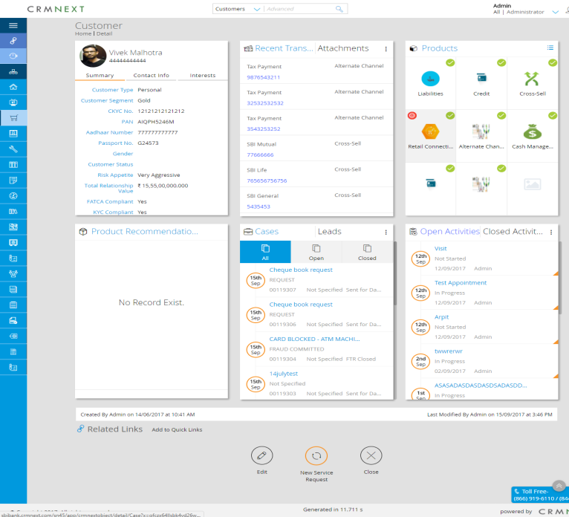

Figure 12: Customer 360 sample

For both type of 360, deal/opportunity view as well as creation functionality will be available through deal/opportunity card.

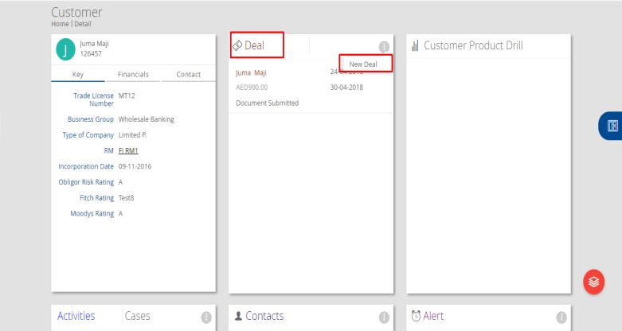

Figure 13-Deal creation initiation

* + - * 1. **More than one Customer** – When the search criteria results in more than one customer search,

Listing Screen – The listing screen, with the customer data as shown in the figure below will appear.

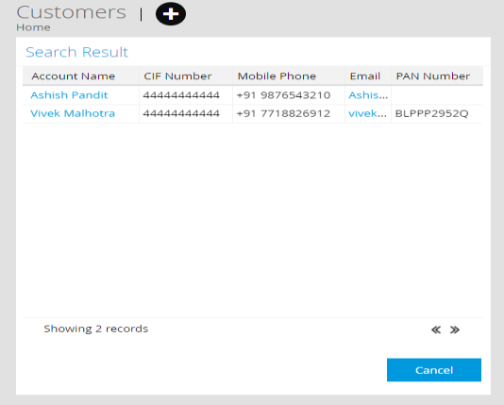

Figure 14: Customer Search Listing

Prospect/Customer 360 navigation: User will navigate to particular customer 360 screen by clicking on the particular Customer Name as provided in the listing.

* + 1. **Outcome 2: Customer Not Found**- Now for this outcome the scenarios are:
       1. No Customer found in CRM database & Core banking system (not a bank customer)
       2. **Screen**: When no customer found basis the given parameter, the “No data found” screen will appear.

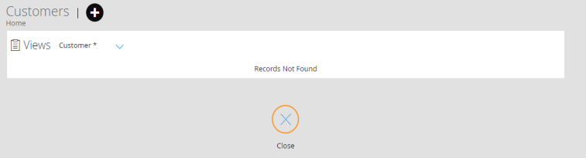

Figure 15: Customer Search

* 1. Further Process (Deal/Opportunity Creation): A new Deal/Opportunity can be created from the Customer 360 using the “New Deal” icon.
  2. Such deals will get tagged against that particular customer.

## Milestone & Status (Stages and Sub Stages)

1. Milestone: They will contain the stages at high level.
   1. It will be common across both segments i.e. CIB & BBD.
   2. They will be same as that current account planning/Deal Stages -as mentioned below:
      1. Opportunity Identified
      2. Client Discussion
      3. Client Application Submitted
      4. Internal Approval Received
      5. External Approval Received
      6. Deal Closed
2. Status Codes: Individual sub stage that a deals goes through in a milestone is status.
   1. Currently all the business groups will operate under the same status codes with in the milestones.
   2. The combination of Milestone with the Status is explained in below fig.

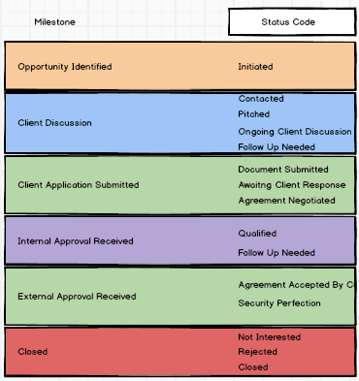

Figure 16: Deal Milestone-Status Relationship for CIB & BB

## Product Bundling Logic

1. As discussed with Bank, Product Bundling logic will not be needed for CIB and BB Customers. (for now, however the Bank is looking at targeting customers in specific sectors, industries through product bundling and pricing value propositions for CIB and BBD and the same sector/industry logic can also be used to recommend next best product)

## Expected Revenue Calculation

On deal creation by RM the intended pipeline will be rolled up and will be calculated on saving the deal. The formula for Calculation is as shown in the below table.

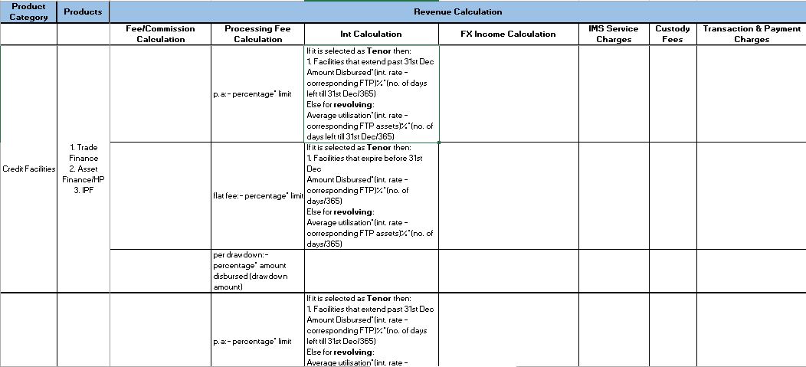

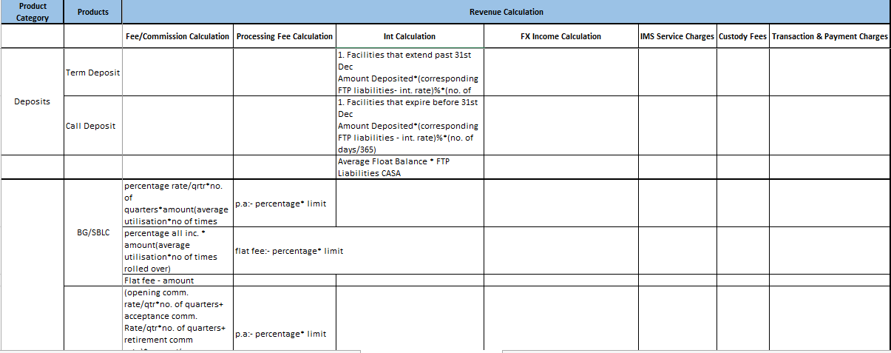

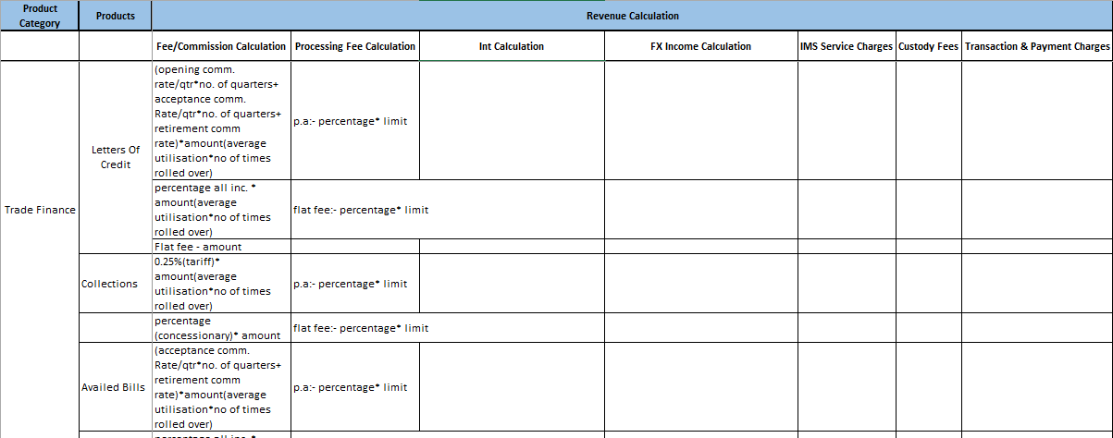

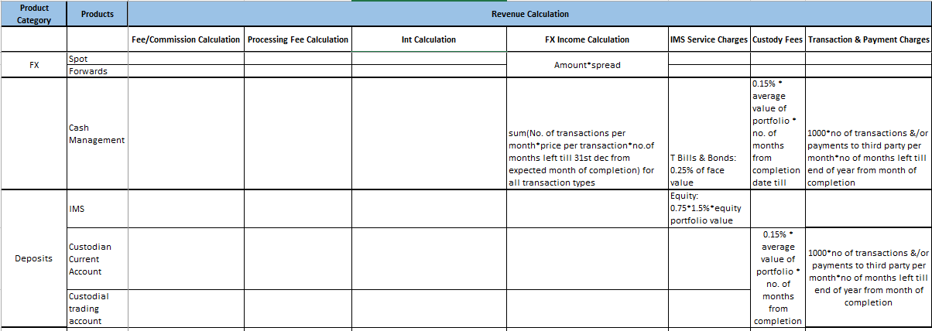

**Attached is the revenue calculation document.**



## Deal Sources

1. Deals will be generated through various channels/sources.
2. Following will be deal types:
   1. Existing Customer Reference: Deals identified as part of account planning process on ETB customers.
   2. Prospects: Opportunities identified for Prospect.
3. Deal source will be captured manually in the system such as
   1. Advertisement
   2. Referral
   3. SMS
   4. Email

Not needed at deal stage– more relevant to leads/prospects unless needed for campaign management for specific products in which case it should be tracked separately under that and not need to be keyed in by RMs for each individual deal

1. The fulfilment process to be followed for the deals created through all the sources will be same.

## Deal Process Description

### ASIS Process

1. Refer to section “ASIS process of Deal Management through Account Planning and SFE Tool” for more details.

### Deal Fields (Confirm with list provided by Charity)

|  |  |  |  |  |  |  |  |  |  |
| --- | --- | --- | --- | --- | --- | --- | --- | --- | --- |
| **Sr. No.** | **Field** | **Field Type** | **Field length** | **Field Validation** | **Editable** | **Lookup** | **Dependent on** | **Mandatory** | **Auto Populate** |
|  | Title | Picker | NA | NA | Yes | Yes | No | Yes | Yes |
|  | Contact First Name | Alphabet | 40 | Only text values. No special characters except for Apostrophe and "-" | Yes | No | No | Yes | Yes |
|  | Contact Last Name | Alphabet | 40 | Only text values. No special characters except for Apostrophe and "-" | Yes | No | No | Yes | Yes |
|  | Company Name | Alphanumeric | 40 | Only text values. No special characters except for Apostrophe | No | No | No | Yes | Yes |
|  | Mobile Number | Number | 10 | Only Number | Yes | No | No | No | Yes |
|  | Email | Email | 30 | Text values. Special characters and numbers allowed | Yes | No | No | Yes | Yes |
|  | Address | Alphanumeric | 60 | Text values. No Special characters. Numbers allowed | Yes | No | No | No | Yes |
|  | Segment | Picker | NA | NA | No | Yes | No | Yes | Yes |
|  | Product Category | Picker | NA | NA | Yes | Yes | No | Yes | No |
|  | Product | Picker | NA | NA | Yes | Yes | No | Yes | No |
|  | Assigned To | Alphanumeric | 40 | NA | No | No | No | No | Yes |
|  | Deal Owner | Alphanumeric | 40 | NA | No | No | No | No | Yes |
|  | Limit/Deal Amount | Decimal | 40 | NA | Yes | No | No | Yes | Yes |
|  | Disburse Amount1 | Decimal | 40 | NA | Yes | No | product = term Loans | Yes | Yes |
|  | Disburse Date 1 | Date | NA | DD/MM/YYYY | Yes | No | product = term Loan | Yes | No |
|  | Disburse Amount2 | Decimal | 40 | NA | Yes | No | product = term Loans | No | No |
|  | Disburse Date 2 | Date | NA | DD/MM/YYYY | Yes | No | product = term Loan | No | No |
|  | Disburse Amount3 | Decimal | 40 | NA | Yes | No | product = term Loans | No | No |
|  | Disburse Date 3 | Date | NA | DD/MM/YYYY | Yes | No | product = term Loan | No | No |
|  | Disburse Amount4 | Decimal | 40 | NA | Yes | No | product = term Loans | No | No |
|  | Disburse Date 4 | Date | NA | DD/MM/YYYY | Yes | No | product = term Loan | No | No |
|  | Disburse Amount5 | Decimal | 40 | NA | Yes | No | product = term Loans | No | No |
|  | Disburse Date 5 | Date | NA | DD/MM/YYYY | Yes | No | product = term Loan | No | No |
|  | Disburse Amount6 | Decimal | 40 | NA | Yes | No | product = term Loans | No | No |
|  | Disburse Date 6 | Date | NA | DD/MM/YYYY | Yes | No | product = term Loan | No | No |
|  | Disburse Amount7 | Decimal | 40 | NA | Yes | No | product = term Loans | No | No |
|  | Disburse Date 7 | Date | NA | DD/MM/YYYY | Yes | No | product = term Loan | No | No |
|  | Disburse Amount8 | Decimal | 40 | NA | Yes | No | product = term Loans | No | No |
|  | Disburse Date 8 | Date | NA | DD/MM/YYYY | Yes | No | product = term Loan | No | No |
|  | Disburse Amount9 | Decimal | 40 | NA | Yes | No | product = term Loans | No | No |
|  | Disburse Date 9 | Date | NA | DD/MM/YYYY | Yes | No | product = term Loan | No | No |
|  | Disburse Amount10 | Decimal | 40 | NA | Yes | No | product = term Loans | No | No |
|  | Disburse Date 10 | Date | NA | DD/MM/YYYY | Yes | No | product = term Loan | No | No |
|  | Deal Id | Number | NA | NA | No | No | No | No | Yes |
|  | Comments | Aggregated | 1024 | Only text values. No special characters Only text values. No special characters such as: `,!,@,#,$,%,*,(,) | Yes | No | No | No | No |
|  | Not Interested/Rejection Reason Code | Picker | NA | NA | Yes | No | Status Code = Rejected | Yes | No |
|  |
|  | Rejected Reason | Alphabet | 512 | Only text values. No special characters Only text values. No special characters such as: `, @,#,$,%,*,(,) | Yes | No | Rejection Reason = Others | Conditional Mandatory | No |
|  | Probability Of Deal | Picker | NA | NA | Yes | Yes | No | No | No |
|  | Status Code | Picker | NA | Status Code will be under milestones | No | Yes | No | No | Yes |
|  | Cust ID | Alphanumeric | 20 | Conditional | No | No | Status Code = Closed | Yes | Yes |
|  | Customer Type | Picker | NA | Values as "Prospect" & "Customer" | No | Yes | No | Yes | Yes |
|  | Internal Approval Attachment | Document | NA | Extension such as pdf,doc,csv,png are accepted | Yes | No | No | Conditional Mandatory on status code = qualified | No |
|  | External Approval Attachment | Document | NA | Extension such as pdf,doc,csv,png are accepted | Yes | No | No | Conditional mandatory on status code=agreement accepted by Customer | No |
|  | Follow Up Date | Date | NA | Date | Yes | No | No | Status Code= Follow Up | No |
|  | Follow Up Time | Date Time | NA | Time | Yes | No | No | Status Code = Follow-up | No |
|  | Deal Type | Picker | NA | NA | Yes | Yes | No | No | No |
|  | Date Of Deal Identification | Date | NA | DD/MM/YYYY | No | No | No | Yes | No |
|  | Expected Month Of Completion | Date | NA | DD/MM/YYYY | No | No | No | Yes | No |
|  | Projected I&M Share Of Wallet | Picker | NA | Picker with % | Yes | Yes | No | Yes | No |
|  | Corresponding FTP | Picker | NA | Picker with values to product | Yes | Yes | Product | Conditional | No |
|  | Currently Used | Picker | NA | Picker with values: Yes, No | Yes | Yes | No | No | No |
|  | Currency | Picker | NA | Picker with values: KES, Others | Yes | Yes | No | No | No |
|  | Annual Average Float | Decimal | 40 | Will accept decimal values | Yes | No | Product= Business Transaction Account | Yes | No |
|  | Fee Amount | Decimal | 40 | Will accept decimal values | Yes | No | Product Category= Cards | Conditional | No |
|  | No Of Cards | Number | 40 | NA | Yes | No | Product Category= Cards | Conditional | No |
|  | No: Of Transaction Per month1 | Number | 40 | NA | Yes | No | Product = Cash Management | Conditional and will be on Transaction type = Salary Processing | No |
|  | Price Per Transaction1 | Decimal | 40 | Will accept decimal values | Yes | No | Product = Cash Management | Conditional and will be on Transaction type = Salary Processing | No |
|  | No: Of Transaction Per month2 | Number | 40 | NA | Yes | No | Product = Cash Management | Conditional and will be on Transaction type = Supplier Payments | No |
|  | Price Per Transaction2 | Decimal | 40 | Will accept decimal values | Yes | No | Product = Cash Management | Conditional and will be on Transaction type = Supplier Payments | No |
|  | No: Of Transaction Per month3 | Number | 40 | NA | Yes | No | Product = Cash Management | Conditional and will be on Transaction type = RTGS | No |
|  | Price Per Transaction3 | Decimal | 40 | Will accept decimal values | Yes | No | Product = Cash Management | Conditional and will be on Transaction type = RTGS | No |
|  | No: Of Transaction Per month4 | Number | 40 | NA | Yes | No | Product = Cash Management | Conditional and will be on Transaction type = B2C | No |
|  | Price Per Transaction4 | Decimal | 40 | Will accept decimal values | Yes | No | Product = Cash Management | Conditional and will be on Transaction type = B2C | No |
|  | No: Of Transaction Per month5 | Number | 40 | NA | Yes | No | Product = Cash Management | Conditional and will be on Transaction type = TTS | No |
|  | Price Per Transaction5 | Decimal | 40 | Will accept decimal values | Yes | No | Product = Cash Management | Conditional and will be on Transaction type = TTS | No |
|  | Tenor | Picker | NA | NA | Yes | Yes | No | Conditional | No |
|  | Rate | Decimal | 40 | Will accept decimal values | Yes | No | No | Conditional | No |
|  | Processing Fee Type | Picker | NA | NA | Yes | Yes | No | Conditional and will have values as:  1. P.A 2. Flat Fee 3. Per Drawdown | No |
|  | Processing Fee Rate | Decimal | 40 | Will accept decimal values | Yes | No | No | Conditional | No |
|  | Average Utilization | Number | 40 | NA | Yes | No | No | Conditional | No |
|  | Times Rolled Over Till End Of this Year | Number | 40 | NA | Yes | No | No | No | No |
|  | Commission Rate Type | Picker | NA | NA | Yes | Yes | No | Conditional and will have values as:  1. Opening 2. Acceptance 3. Handling  4.retirement | No |
|  | Commission Rate | Decimal | 40 | Will accept decimal values | Yes | No | No | Conditional | No |
|  | Re-Payment Type | Picker | NA | NA | Yes | Yes | No | Conditional and will have values as:  1. Bullet 2. EMI | No |
|  | No Of Payments | Number | 20 | NA | Yes | No | No | No | No |
|  | Re-Payment Date 1 | Date | NA | DD/MM/YYYY | No | No | No | Yes | Yes |
|  | Re-Payment Amount 1 | Decimal | 40 | Will accept decimal values | Yes | No | No | Conditional | No |
|  | Re-Payment Date 2 | Date | NA | DD/MM/YYYY | No | No | No | Yes | Yes |
|  | Re-Payment Amount 2 | Decimal | 40 | Will accept decimal values | Yes | No | No | Conditional | No |
|  | Re-Payment Date 3 | Date | NA | DD/MM/YYYY | No | No | No | Yes | Yes |
|  | Re-Payment Amount 3 | Decimal | 40 | Will accept decimal values | Yes | No | No | Conditional | No |
|  | Re-Payment Date 4 | Date | NA | DD/MM/YYYY | No | No | No | Yes | Yes |
|  | Re-Payment Amount 4 | Decimal | 40 | Will accept decimal values | Yes | No | No | Conditional | No |
|  | Re-Payment Date 5 | Date | NA | DD/MM/YYYY | No | No | No | Yes | Yes |
|  | Re-Payment Amount 5 | Decimal | 40 | Will accept decimal values | Yes | No | No | Conditional | No |
|  | Re-Payment Date 6 | Date | NA | DD/MM/YYYY | No | No | No | Yes | Yes |
|  | Re-Payment Amount 6 | Decimal | 40 | Will accept decimal values | Yes | No | No | Conditional | No |
|  | Re-Payment Date 7 | Date | NA | DD/MM/YYYY | No | No | No | Yes | Yes |
|  | Re-Payment Amount 7 | Decimal | 40 | Will accept decimal values | Yes | No | No | Conditional | No |
|  | Re-Payment Date 8 | Date | NA | DD/MM/YYYY | No | No | No | Yes | Yes |
|  | Re-Payment Amount 8 | Decimal | 40 | Will accept decimal values | Yes | No | No | Conditional | No |
|  | Re-Payment Date 9 | Date | NA | DD/MM/YYYY | No | No | No | Yes | Yes |
|  | Re-Payment Amount 9 | Decimal | 40 | Will accept decimal values | Yes | No | No | Conditional | No |
|  | Re-Payment Date 10 | Date | NA | DD/MM/YYYY | No | No | No | Yes | Yes |
|  | Re-Payment Amount 10 | Decimal | 40 | Will accept decimal values | Yes | No | No | Conditional | No |
|  | Spread | Decimal | 20 | Will accept decimal values | Yes | No | No | Conditional | No |
|  | Portfolio/Asset Value | Decimal | 20 | Will accept decimal values | Yes | No | No | Conditional | No |
|  | IMS Type | Picker | NA | NA | Yes | Yes | Product = IMS Services | Will have values as:  1. Government Security 2. Equity | No |
|  | Face Value | Decimal | 20 | Will accept decimal values | Yes | No | Product = IMS Services | Conditional, IMS Type=Government Security | No |
|  | Brokerage Value | Decimal | 20 | Will accept decimal values | Yes | No | Product = IMS Services | Conditional, IMS type=Equity | No |
|  | Kes Deal Amount | Decimal | 20 | Will accept decimal values | Yes | No | Product = IMS Services | Conditional | No |
|  | Facility | Picker | NA | 1. Tenor  2. Revolving | Yes | Yes | Product | Conditional | No |
|  | Closed Date | Datetime | NA | NA | No | No | All Products | No | Yes |

Table 8 Deal Process Fields

### Deals Product Depending Fields as per SFE Web Tool



### Proposed Process

1. Current process combines
   1. Customer 360
   2. Account planning and Wallet sizing &
   3. Deal process
2. In proposed solution through “Bank CRM”- the above said sub processes will be segregated to serve the business requirements well.
3. The Customer 360 will contain various section inclusive of
   1. Customer Profile
   2. Account Planning
   3. Deals etc.
4. The Deals Tab/Card will list all the current Deals and previous deals executed against a particular customer.

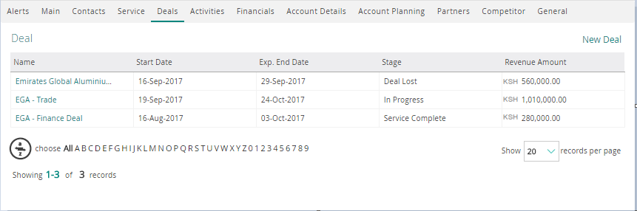

Figure 17: Deal Listing on Customer 360

### Stages/Milestones Description

The stages/milestones for the deal process will be:

###### Opportunity Identified

1. Opportunity Identified will the first milestone in the journey of deal/Opportunity.
2. This will comprise of following sub-processes/Sub-stages/Status Codes:
   1. **Initiated**
      1. Customer Search:
         1. The RM will search the customer/Prospect. This will provide 2 types of customers
            1. ETB- Customers
            2. NTB- Prospects
         2. The process of deal management will remain same for both Customers as well as prospects.
         3. The RM will be routed to Prospect/Customer 360 as per the type of customer.
         4. The deal will be created on the Prospect or the Customer from respective 360 screen.
      2. Data entry: Business RM will create the deal in the “Bank CRM”.
         1. When any new deal will be created, the respective relationship manager, Relationship Analyst & Product House Representative will receive an alert stating the same.
         2. The Deal/Opportunity owner will remain the Self/RM.
         3. The Deal/Opportunity will be assigned to corresponding product house representative or RM where applicable.
         4. The RM as well as Product house representative can take action on same.
         5. At the time of Opportunity/Deal creation RM can define the action item list as system Tasks, Activities and appointments and assign them to individual RM, RA or Product house representatives for the action.
            1. The sales action list items will be tracked through these system activities and status of same will be available on deal 360 card as well as details tab.
      3. Screen Details
         1. Business RM will create the deal in the system via following screen

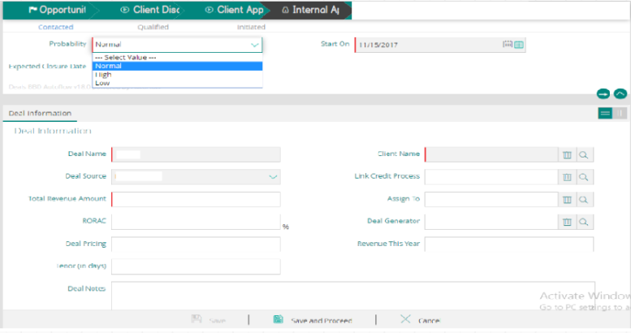

Figure 19: Illustrative Deal creation screen

* + - 1. Fields marked in red will be Mandatory fields.
      2. There will be certain conditional mandatory fields as well.
      3. Whenever a mandatory field will be left blank before saving deal, an error message will appear for each field.
      4. The fields will also include-
         1. In-built pickers

Date Calendar

Master data List pickers (dropdowns)

Products etc. (List with search features)

* + - 1. The deal can be either saved or it could be save and proceed.
         1. **Save**: Deal saved in the same status
         2. **Save and proceed**: Deal can be moved to the next status
         3. **Cancel**:Cancel will mean data entry is not be saved



Figure 21: Deal save options

* + - 1. Also the various milestones will be visible on the deal edit page along with possible status codes to choose from.



Figure 22: Deal save options

###### Client Discussion

1. Client Discussion will be second milestone in the journey of deal
2. It will comprise of following sub-processes/Sub-Stages/Status Codes:
   1. **Contacted** 
      1. In this stage the concerned customer will be contacted and the notes of the discussion will be appended in the existing deal.
      2. This will be performed either by the RM of the deal or the respective product house representative.
   2. **Pitched** 
      1. The users will make multiple contacts with the customer so as to decide what all products to be pitched through the ongoing deal.
      2. User will be able to select multiple products for one deal.
   3. **Ongoing Client Discussion**
      1. This step will include the Offer generation, negotiation with the customer and approval of customer.
      2. RM will negotiate with the customer and update the deal in “Bank CRM”.
   4. **Follow Up Needed**
      1. This step will illustrate if any follow up is required based on the Client Discussion.
      2. Accordingly, the RM will update the status of the deal in “Bank CRM”.
3. With each moving status, the progress field will keep on updating so as to show the journey fulfilled till date.
4. At any given stage user will see the milestones as follows:
   1. **Next possible actions**: they will be proposed by clicking in the right
   2. **Color code**:
      1. **COMPLETED**
      2. **CURRENT STAGE**
      3. **NEXT POSSIBLE**
      4. **LOCKED**



Figure 23: Progressive Milestone

###### Client Application Submitted

1. Client Application Submitted will be third milestone in the journey of deal.
2. It will comprise of following sub-processes/Sub-Stages/Status Codes:
   1. **Document Submitted**: RM will prepare all the documentation related to the respective deal and will update it in Bank CRM as document submitted.
   2. **Awaiting Client Response**: Based on the discussions with Customer, the deal amount and terms and conditions will be arrived.
   3. **Agreement Negotiated**: This is the final negotiation before approvals between bank and customer party.
      1. The expected Revenue will be calculated at this stage for the review.
      2. This step will be performed outside the “Bank CRM”, where all the concerned product partners and RMs will discuss and reach to a conclusion of either the Deal being good enough to be processed or it’s a lost deal.

###### Internal Approval Received

1. Internal Approval Received will be the fourth milestone in the journey of the deal.
2. It will comprise of following sub-processes/Sub-Stages/Status Codes:
3. **Qualified**:
4. The deal will be send to Committee for approval outside “Bank CRM”. Once Approved by Committee, post receipt of approval email RM will approve the Deal and attach the approval email in Corporate 360.**Follow Up Needed**
   1. This step will illustrate if any follow up is required based on the Approval Received.
   2. Accordingly, the RM will update the status of the deal in “Bank CRM” with the Follow Up date and time.

###### External Approval Received

1. External Approval Received will be the fifth milestone in the journey of the deal.
2. It will comprise of following sub-processes/Sub-Stages/Status Codes:
3. **Agreement Accepted by Customer**:
   1. This step will be performed outside the “Bank CRM”, where RM as well as product partners will get the final confirmation from Customer on the deal.
   2. Once decided positively the RM/PH representative will update the deal status within “Bank CRM” including any expected revenue re-calculation.
4. **Security Perfection**
   1. This step will illustrate if any follow up is required based on the Approval Received.
   2. Accordingly, the RM will update the status of the deal in “Bank CRM” with the Follow Up date and time.
   3. Further Processing- The record will then be send to Finacle/LOS (Core Banking I&M as the case may be) for further processing.
   4. Deal Processing- in Finacle/LOS (Core Banking I&M)
      1. Once the processing in Bank CRM is completed, deal will be handed off for fulfillment to Finacle/LOS (Core Banking I&M).

Deal Status Update

Deal handoff for further processing

CRMNEXT

FINACLE/LOS

Figure 24 Deal Handoff to Core System

###### Deal Closed

1. Deal Closed will be the last milestone in the journey of the deal.
2. It will comprise of following sub-processes/Sub-Stages/Status Codes:
3. **Completed**:
   1. The team will do final review with Customer including the first payment fee receipt.
   2. As the status of deal advances in the fulfilling system; the status will be updated back in Bank CRM.
      1. This update will be through a web service call from the fulfilling system to “Bank CRM” or through periodic batch processing. I&M Bank to confirm on the approach based on discussion with Finacle Team considering current upgrade of Finacle).
   3. Once the deal is approved in core banking and first fee payment is received, the RM will update the status to “Deal Completed”.
   4. Thus process ends at this stage.
   5. An alert will be sent to servicing team at this point.
   6. The Account details will move to Bank CRM from core banking/LOS/Vision through day end batch jobs.
4. **Not Interested**:
   1. This status code will be available at all status codes and the RM can mark the deal as “Not Interested” with the specific reason in the comment section. The Not interested reason will be mandatory while moving the status code to “Not Interested” status code.
5. **Rejected**:
   1. This status code will be available at all status codes and the RM can mark the deal as “Rejected” with the specific reason in the comment section. The Rejected reason will be mandatory while moving the status code to “Rejected” status code.

## **Activities (Tasks & Appointments)**

1. When user will login into “Bank CRM” System, the first section will consists of the Activities, inclusive of the Tasks and Appointments aligned by Day, Week and Month.
2. This will provide the user a consolidated view of how to organize their calendar.
3. The Tasks that have been assigned to the Official will have due dates associated to it.
4. “BANK CRM” will have an escalation hierarchy as per the roles of the Official.
5. The user can/will also create tasks and appointments for themselves using this activities section.

### Tasks

1. The Task page will be used by the user to log a task for his/her internal reference.
2. The user will keep a track of the tasks taken during the process of Prospect/Deal Management/Customer 360 as well as his own internal activities.
3. The card will show the tasks assigned to the logged in user. The user can view these using the filters:
   1. “Today” for showing all tasks scheduled for today,
   2. “Next 7 Days” for showing all tasks scheduled for the next 7 days
   3. ”Month” will give a calendar view showing all tasks scheduled for the selected month.
4. The user will be able to change the month using the arrows.
5. The user will be able to directly add a new task by clicking the “+” sign which will open the tasks layout/form that asks the user to fill the required details to create a task.
6. On click of the “More” button at the bottom of the card, the user will be directed to the tasks Home page.

### Wireframes

1. Summary Page

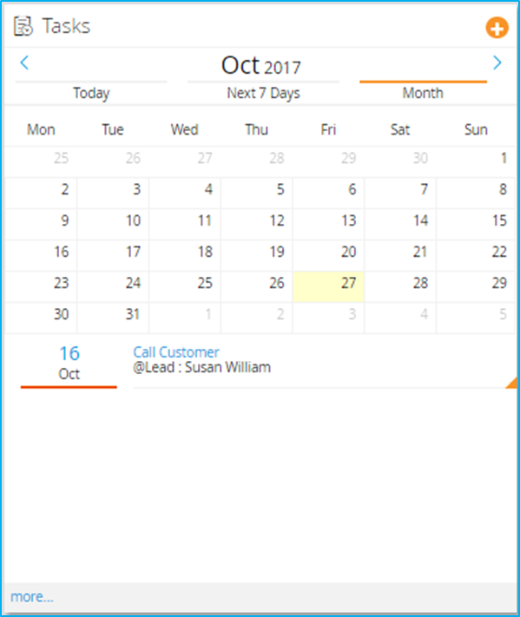

Figure 25-Illustrative Tasks Screen

1. Task New/Edit from Summary Screen

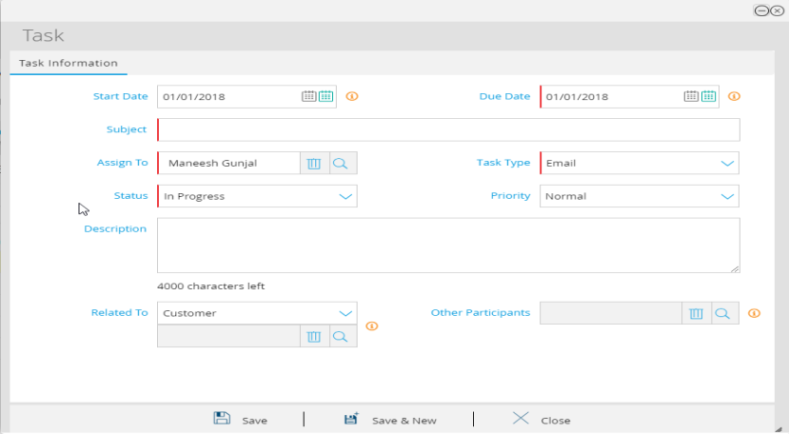

Figure 26- Illustrative Task Create/Edit from Summary screen

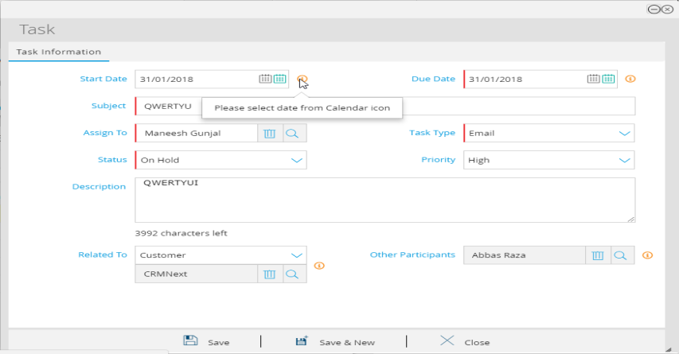

Figure 27- Illustrative Task Create/Edit from Summary screen

1. Task View from Summary Screen

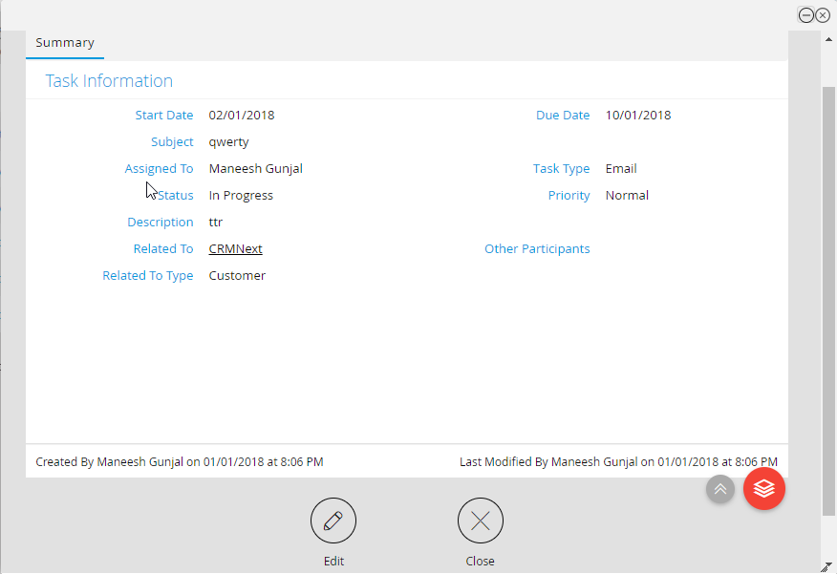

Figure 28- Illustrative Task Details from Summary screen

1. Error Message on Task Creation when Due Date is prior to Start Date

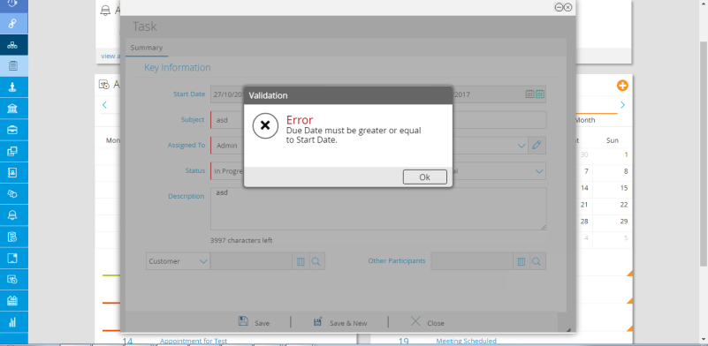

Figure 30- Illustrative Error Message on Task Creation when Due Date is prior to Start Date

### Appointments (call report discussed and template provided)

1. The Appointments will be used by the user to log an appointment with the customer.
2. The user will keep a track of the appointments taken with the customer during the process of Prospect/Deal Management or for planned discussions.
3. Appointment creation date will be Future Date or Past date for better tracking.
4. The card will show the appointments assigned to the logged in user. The user can view these using the filters:
   1. “Today” for showing all appointments scheduled for today,
   2. “Next 7 Days” for showing all appointments scheduled for the next 7 days
   3. ”Month” will give a calendar view showing all appointments scheduled for the selected month.
5. The user will be able to change the month using the arrows.
6. The user will be able to directly add a new appointment by clicking the “+” sign which will open the tasks layout/form that asks the user to fill the required details to create a task.
7. On click of the “More” button at the bottom of the card, the user will be directed to the appointments Home page.

### Wireframes

1. Summary Page

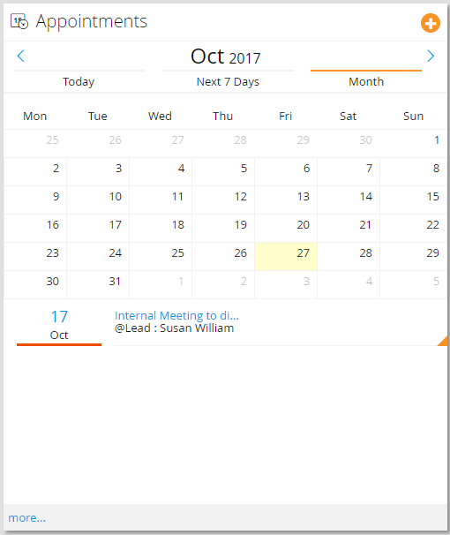

Figure 31- Illustrative Appointments screen

1. Appointment New/Edit from Summary Screen

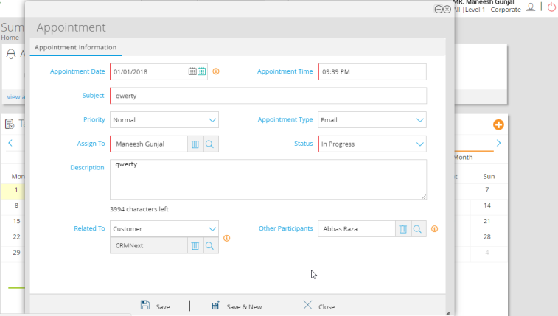

Figure 32- Illustrative Appointment Create/Edit from Summary screen

1. Appointment View from Summary Screen

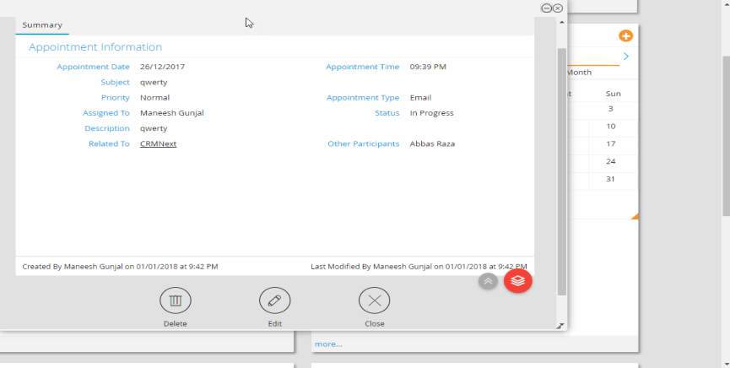

Figure 33- Illustrative Appointment View from Summary screen

# Client Coverage Profile & Meeting History

1. This section defines the Client Coverage profile and the meetings that the respective RM has conducted with potential or existing Customer which he has met.
   1. The task and activities can also be created by Product House representatives.

# Assignment Logic

1. The Assignment logic is mentioned below:
2. Bulk Assignment –
   * 1. The “Assigned To”/ “Process Champion” of deal using this functionality will assign Single/multiple deals to other RMs individually/as well as in bulk manner.
        1. The deal will be available in view to “Assigned To”.
        2. The “Assigned To” can select deals one by one or all at once using selection box and assign deals by clicking “Allocate” action button.
        3. The assignment will take place within same segment.

| Sr. No. | Start  Condition | Action | Action Type | Process | End Result |
| --- | --- | --- | --- | --- | --- |
|  | Assigned to CIB-RM | Update | Manual | The deal will be assigned to CIB-RM of the customer/prospect when created through customer 360. | The deal will be assigned to CIB-RM |
|  | Deal Owner to another CIB-RM | Update | Manual | The deal owner will be changed to another RM. | The deal will be assigned to CIB-RM |
|  | Deal Owner to PH- Partner | Update | Manual | The deal owner will be changed to selected PH partner. | The deal will be assigned to CIB-RM |

Table 9 Deal Assignments

# Escalation Matrix

1. The escalation matrix is listed below:

| S. No. | Trigger Condition | 1st Level Escalation (Hours) | 2nd Level Escalation (Hours) | 3rd Level Escalation (Hours) |
| --- | --- | --- | --- | --- |
| 1 | Status Code = In current Status Code and no movement to next status code | Deal Expected Closure Month Last date -20 | Deal Expected Closure Month Last date -5 | Deal Expected Closure Month Last date |

Table 10 Escalation table

1. Escalation will be sent to the below users based on the user reporting hierarchy and not the level of role.
   1. Level 1: Relationship Manager
   2. Level 2: Relationship Manger + Champion
   3. Level 3: Champion + Segment Head

To discuss with Stephen

# Alerts Matrix

1. Alerts on Deals/Account Opening different from Alerts on Customer (available in the customer management document).
2. The list of the alerts is listed in the table below: (Proposed by CRMNEXT - Business to Confirm)

|  |  |  |  |  |
| --- | --- | --- | --- | --- |
| Sr. No. | Alert On | Trigger Conditions | Recipient | Mode Of Alert |
|  | Deal Approved | Agreement Negotiated | Assigned to (user selected by RM for approval) | System Alert |
|  | Alert to account team on creation of new deal on customer | New deal created | Account team marked on Customer | System Alert |
|  | Handover to service alert | Deal Status=Win/Closure | Service team | System Alert |
|  | Appointment  Email notifications to client. | Appointment Due Date = Current Date + 1 (On Appointment Creation and/or completion an email needs to be sent to the Customer.) | Owner, Assigned To, Appointment Related To | System Alert |
|  | Notification to Assigned to and Owner | Deal Status Code has changed | Assigned To, Deal Owner | System Alert(conditional Alert) |

Table 11: Alert table

# Views

1. The list of views that would be available are listed in the table below:

| **Sr. No.** | **Name of the View** | **Description** | **Columns** | **Access To** | **Scope of View** | **Action Button** |
| --- | --- | --- | --- | --- | --- | --- |
| 1. 1 | Prospect | This will list the new prospect created in the system and will be visible to the Owner of the prospect and the seniors in the hierarchy above. | Company Name, Segment, Customer Type, Group Name & Company Registration Number, RM | All | Individual |  |
| 1. 3 | Deals | All the deals will be shown along with columns such as and will be listed in this view for the deal Owner and its hierarchy | Account Number, Customer Id, Product, Deal Amount, Size of Wallet, Projected I&M share of wallet, Expected I&M Revenue, Assigned To, Deal Owner, Alternate RM, status Code | All | All | Re-Assign |

Table 12 List of Deal Views

# Budgeting, Account Planning and Achievements

## **ASIS Process**

Budgeting for Bank

Wallet Sizing across ETB CIB Accounts by RMs for Products

Account Planning across ETB CIB Accounts by RMs for Products

Deal Process across ETB CIB Accounts by RMs & PH Reps for Products.

Deal Pipeline & Gap Analysis across RMs

Budget distribution across RMs

Deal Pipeline & Gap Analysis across Bank

Yearly

Yearly

Throughout the Year

Throughout the Year

Throughout the Year

Throughout the Year

Throughout the Year

Figure 1 ASIS Account Planning Process

1. The current working process of Account planning in bank is as follows.
   1. Budgeting is done across RMs in BI Vision
   2. The Account Planning sheet is currently used by bank for all Corp accounts, IB accounts with more than 250k in revenue and BB accounts more than KSH 3M yearly revenue.
   3. As part of account planning, RM sets target for himself against the Budget allocated to him.
      1. RM studies the wallet share details against individual account and products used by an Account
      2. Sets Target for himself as part of Wallet Share against individual products.
      3. This Target – is treated as Deal to be achieved (Pipeline).
   4. The Deal Pipeline vs Gap Analysis is tracked through separate excel sheets.
   5. The current process of account planning, wallet sizing and Deal management is done through multiple excel worksheets and VB macros where
      1. Customer360 is combined with Account planning.
      2. Deal management is combined with Account planning.
      3. Wallet Sizing is separately tracked and not combined with Account planning- it’s part of deal management
      4. No Foreign currency conversion is involved – it is involved but at deal input stage so no way for reviewer to know currency. To discuss further on up to date FTPs and FX rates for open deals.

## Proposed Processes

### Budget Setting

1. The ASIS Budgeting process will remain intact and continue to take place in Vision at RM level.
2. This Budget data will be pulled from BI Vision in batch mode format and will be shown in Read-only format in reports as well as dashboard format.
3. The Budgeting data for whole year will be uploaded from Vision on Monthly basis on last day of current month through Batch process.
4. The whole of Budget data for the current year will be deleted and re-uploaded on monthly basis in Bank CRM.

### Wallet Sharing

1. The Wallet Sharing Process taken at excel sheet level has been removed in current SFE Web Portal. This will also be removed in Bank CRM.

### Wallet Sizing

1. The Wallet Sizing will be carried out through expected Revenue for the deals across all accounts and RMs.
2. Please refer to Deal process and product wise dependent field list for further details along with corresponding formulae.
3. This Wallet data will be pulled from BI Vision in batch mode format and will be shown in Read-only format in reports as well as dashboard format.

### Achievements

1. The ASIS Achievement process will remain intact and continue to take place in Vision at RM and account level.
2. This Achievement data will be pulled from BI Vision in batch mode format and will be shown in Read-only format in reports as well as dashboard format.
3. The Achievement data for whole year will be uploaded from Vision on Monthly basis on last day of current month through Batch process.
4. The whole of Achievement data for the current year will be deleted and re-uploaded on monthly basis in Bank CRM.

### Account Planning

1. The Account Planning will be done at RM Level by pulling previous year Achievements from Vision for RM and showing in read-only format (editable for current year).
2. The Account Planning data will be pulled from BI Vision in batch mode format and will be shown in Read-only format in reports as well as dashboard format.
3. The Account Planning data for whole year will be uploaded from Vision on Monthly basis on last day of current month through Batch process.
4. The whole of Account Planning data for the current year will be deleted and re-uploaded on monthly basis in Bank CRM.

### Pipeline Analysis

1. There will be 2 ways by which the Pipe line data will be calculated and compared with Gap (Budgeted- Achievement).
2. Option1 (not applicable anymore)
   1. The Deals details along with expected Disbursement, Repayment details along with expected revenue will be sent to Vision at Product, Account and RM level.
   2. The Pipeline will be calculated in Vision by rolling up the expected revenue till RM level and subtracting the Achievements against that RM till date available in Vision. (only applies to term loan though)
   3. This way, Vision will also have expected pipeline information against Budget and Achievements.
   4. These Gap Analysis details will be send back to Bank CRM from Vision to show in reports and Dashboard format.
   5. The whole process will be carried out on monthly basis as month end batch job.
3. Option2 **For now this is the only applicable option**
   1. The Deals details along with expected Disbursement, Repayment details and expected revenue will remain in Bank CRM at Deals Level.
   2. The expected revenue will be calculated in Bank CRM by rolling up the expected revenue till RM level.
   3. The Budget vs Achievement data at CRM level will be send to Bank CRM from Vision. This data will be compared against Expected Revenue Income in Bank CRM and multiple Gap Analysis Reports/Dashboards will be shown at RM Level.
   4. This way, Bank CRM will also have expected pipeline information against Budget and Achievements.
   5. The whole process will be carried out on monthly basis as month end batch job.

### Budget VS Actuals Report vs Pipeline (Bank + RM)

1. This report will showcase the sum of Budgets across all RM’s and the sum of actuals achieved by the respective RM’s along with the pipeline



Figure 12 Budget vs Actual calculations

Figure 13 Budget vs Actual vs Pipeline Analysis Report

1. This report will track the performance of the RM as well as Bank in terms of Budget vs Actual including pipeline details.
2. The report will be available at RM level as well as for the Bank.

### Planned VS Actuals Report (RM Level)

1. This report will serve as indicative for RM to assess the current actuals achieved so far with respect to planning done per account and will also be showcasing the Deals pipeline currently in progress.



Figure 14 Account Planning vs Actual & Gap Calculation

1. This report will be available at RM level.

Figure 15 Account Planning vs Actuals vs Pipeline

### Pipeline VS Expected Pipeline vs Budget Gap (RM + Bank)

1. This report will showcase the total pipeline at present and the expected achievement of these pipelines based on the “hit rate” along with the gap between budgets and actuals.
2. The same report can also include the filters of deal owners that can help track the performance of the RM’s
3. A comparison between the gap and expected achievement will indicate that additional account planning required from RM’s to create more deals because the existing pipeline may not enough be enough to achieve the target.

Figure 16 Pipeline vs Expected Pipeline vs Gap at Budget analysis

### Effect of movement of RM on over all planning

1. The movement of RM will not affect following in “Bank CRM” the below mentioned process take place in BI Vision and will handled in Vision.
   1. Budgeting
   2. Account Planning
   3. Achievement
2. Deals and In Progress calculation
   1. The Open deals against previous RM will be assigned to new RM by “Process Champion”.
   2. The RM at account level also be changed by “Process Champion”.

# IDR Session Points

|  |  |  |  |  |  |  |  |  |
| --- | --- | --- | --- | --- | --- | --- | --- | --- |
| **Sr#** | **Points is discussed** | **Status** | **Owner** | **Date Logged** | **Date Closed** | **Description** | **Reports** | **Integration Touch Point** |
| 1 | RFP discussion will be taken post completion of IDR functional walk through to check completeness of RFP and arrive at CRs, work Around and decommissioned points. | Pending | CRMNEXT | 16-May-18 |  | This will be discussed with bank during 4th week in IDR. |  |  |
| 2 | Come up with Integration touch point list and to mark preferred mode of Integration (to decide Realtime and Batch mode). The list will contain following columns 1. Touch Points description 2. What details of touch points to be covered 3. Pain/Challenges for getting details from other systems 4. expected time line  5. Feasibility to be done on current or new system | Pending | CRMNEXT | 16-May-18 |  | This list will be prepared along with functional IDR sessions and will be shared at end of every week with bank. |  |  |
| 3 | Fin 7 to Fin 10 migration is on cards. Expected timelines is Mar 2019. Need to work along with Finacle team see feasibility on carrying out integration on Finacle 10. | Pending | CRMNEXT | 16-May-18 |  | This will be discussed with Finacle during 3rd week into IDR. |  | Y |
| 4 | IT Roadmap:  Finacle core 7 to 10 Treasury 11 to 12 internet banking/Mobile banking- Omni Channel Phase 1- 30 June 18 Phase 2- Mar 19 Card System will change- prepaid this month Debit card- June CC - Oct | Pending | CRMNEXT | 16-May-18 |  | Need to check impact of Road map and suggest the feasibility as per points# 2 &3. |  |  |
| 5 | Eligibility criteria to be given by bank - whether corporate qualify for account planning. This is just for reporting purpose.  However, account planning and deal management process will be available to all CO&IB and BB banking customers. The lead process will be provided to all 4 segments. | Decision Made | Bank | 16-May-18 | 16-May-18 | Decision made as mentioned under description. | Y |  |
| 6 | ~~Expected closure date~~ Expected Month of closure will be mandatory on deals. Change of Deal end date- New status code "Follow-up" to be added. Which will facilitate the movement of deal across financial and account planning. The follow-up status code will be added post "ongoing client discussion" status code specifically to change the expected closure date. | Decision Made | Bank | 16-May-18 | 17-May-18 | Decision made as mentioned under description. |  |  |
| 7 | Account Planning will be financial year specific. | Decision Made | Bank | 16-May-18 | 16-May-18 | Decision made as mentioned under description. | Y |  |
| 8 | Corporate RM will create deal and will get assigned to himself. However, he can re-assign it manually to product house owners or other RM to work. | Decision Made | Bank | 16-May-18 | 16-May-18 | Decision made as mentioned under description. |  |  |
| 9 | Predictive Offers won't be there for Corporate & Institutional Banking and will be there for Business Banking. Logic to show it on the Business Banking Customer to be shared by I&M | Pending | Bank | 16-May-18 |  | Finalization of logic to be made |  |  |
| 10 | Integration systems for Corporate 360: LOS Finacle Vision for revenue+ Card data IMS Trade Finance Finacle Treasury Banc assurance DMS Finacle OMNI Channels | Pending | CRMNEXT/Bank | 16-May-18 |  | This will be taken up at 2 levels 1. Finalisation of fields and integrations during functional IDR 2. Technical Integration methodology during discussions with Vendor. |  | Y |
| 11 | Forex rate -same T-1 feed going to Vision from core will be provide to CRMNext as well. This is needed for conversion on deal page.  Forex rate for converting USD into KSH change on daily basis. When deal amount is entered in USD from KSH then current forex required to come and populate on other | Decision Made | Bank | 16-May-18 | 16-May-18 | Decision made as mentioned under description. |  | Y |
| 12 | The current account planning sheet will be divided into 3 sections namely 1. Corporate 360 sections- pertaining to information about customer from various systems as well as manually enterable details. 2. Wallet Sizing and Account planning will be handled as part of Account Planning Process 3. Deals will be separated from Account Planning. However, account planning will show corresponding multiple deal details. | Decision Made | Bank/CRMNext | 16-May-18 | 16-May-18 | Decision made as mentioned under description. |  | Y |
| 13 | All product house partners will be captured. Currently excel has provision for only 4. These will be manually selected in CRMNEXT by RM and will not go to Core banking or any other system. | Decision Made | Bank/CRMNext | 16-May-18 | 16-May-18 | Decision made as mentioned under description. |  | Y |
| 14 | Account Revenue, Client Financials, Credit Information to be fetched from LOS | Decision Made | Bank/CRMNext | 16-May-18 | 16-May-18 | Decision made as mentioned under description. |  | Y |
| 15 | Value Chain (distributors and Suppliers) will be created as contacts on customer 360 manually. One time boot up migration will be done from Web Based SFE tool to assists RMs on data entry. | Decision Made | Bank/CRMNext | 16-May-18 | 16-May-18 | Decision made as mentioned under description. |  | Y |
| 16 | Employee details will be manually enterable on corporate 360 details page. | Decision Made | Bank/CRMNext | 16-May-18 | 16-May-18 | Decision made as mentioned under description. |  |  |
| 17 | Qualitative Information will be manually enterable on corporate 360 details page. | Decision Made | Bank/CRMNext | 16-May-18 | 16-May-18 | Decision made as mentioned under description. |  |  |
| 18 | Competition/Competitor Information will be manually enterable on corporate 360 details page. | Decision Made | Bank/CRMNext | 16-May-18 | 16-May-18 | Decision made as mentioned under description. |  |  |
| 19 | Client Coverage profile and Meeting History Information will be manually enterable on corporate 360 details plus Lead details through appointments. | Decision Made | Bank/CRMNext | 16-May-18 | 16-May-18 | Decision made as mentioned under description. |  |  |
| 20 | Reports - highlighting missed appointments as well as tasks will be made available. | Decision Made | Bank/CRMNext | 16-May-18 | 16-May-18 | Decision made as mentioned under description. | Y |  |
| 21 | Sales Action List will be achieved through appointments and Tasks on Deals. Their status will be tracked by drilling through deals view and deals details/Card View. | Decision Made | Bank/CRMNext | 16-May-18 | 16-May-18 | Decision made as mentioned under description. | Y |  |
| 22 | Wallet Sizing- Do not refer to excel sheet. The demo will be arranged on web version of account planning tool and needs to consider the same to complete wallet sizing. | Pending | Bank/CRMNext | 16-May-18 | 17-May-18 | Decision made as mentioned under description. |  |  |
| 23 | Integration with DMS needs to happen to show the security documents. Also, the below details to be provided as one time upload in CRMNext for every customers across all segments. Once uploaded, the individual values will be modified in CRMNext. If no details loaded as one time boot up, the values will be available in modifiable mode. 1. Type of Security 2. Market Value 3. Charge Value 4. Insurance Valuation Report 5. Insurance Valuation Date Though valid for borrowing customers, will be applicable for all customers across segments. The details will not be linked to any system. | Decision Made | Bank/CRMNext | 16-May-18 | 16-May-18 | Decision made as mentioned under description. |  | Y |
| 24 | Prospect will be created by RM as first step towards opportunity/Deal creation for NTB customers. The Opportunity will have bare minimum fields. The ~~Company Registration Number and Pin number (tax details) will be unique and mandatory for prospect~~ creation. However, as discussed on 17th Dec both fields will be optional and Postal Code and PO Box fields will be mandatory. | Decision Made | Bank/CRMNext | 16-May-18 | 17-May-18 | Decision made as mentioned under description. |  |  |
| 25 | No Budgeting process in CRMNEXT will be provided. The details are available in Vision and will continue to be handled inside Vision. | Decision Made | Bank/CRMNext | 16-May-18 | 16-May-18 | Decision made as mentioned under description. | Y | Y |
| 26 | No Achievement process in CRMNEXT will be provided. The details are available in Vision on drawdown amount and will continue to be handled inside Vision. | Decision Made | Bank/CRMNext | 16-May-18 | 16-May-18 | Decision made as mentioned under description. | Y | Y |
| 27 | No Expected BAU in CRMNEXT will be provided for existing closed deals. The details are available in Core Banking and will be computed in Vision. However, till vision is not available with expected BAU, the approx. formulae will be applied in the view of Vision to get extracted and loaded in CRMNext. | Decision Made | Bank/CRMNext | 16-May-18 | 16-May-18 | Decision made as mentioned under description. | Y | Y |
| 28 | Along with Expected BAU, the below fields will be made available in Vision view 1. Avg. TNR/Client YTD 2. Reqd. Avg. TNR/Client YTD 3. FY Reqd. Avg. TNR/Client  4. Cross Sell (will be added in the BI system) 5. Required Cross sell(will be added in the BI system) | Decision Made | Bank/CRMNext | 16-May-18 | 16-May-18 | Decision made as mentioned under description. | Y | Y |
| 29 | The Budget, Achievement and expected BAU data will be provided by Vision at RM, Segment and month wise for 12 months as month end Batch Job. The same job will also populate the pipe line from CRMNext through Lead & Deal Management modules. | Decision Made | Bank/CRMNext | 16-May-18 | 16-May-18 | Decision made as mentioned under description. | Y | Y |
| 30 | This data will be summarised and made available in form of dashboard on landing page of RM. | Decision Made | Bank/CRMNext | 16-May-18 | 16-May-18 | Decision made as mentioned under description. | Y |  |
| 31 | This data will be summarised and made available in form of dashboard report to be shared with leadership. | Decision Made | Bank/CRMNext | 16-May-18 | 16-May-18 | Decision made as mentioned under description. | Y |  |
| 32 | Deal/Lead pipeline drill down dashboard to be made available | Decision Made | Bank/CRMNext | 16-May-18 | 16-May-18 | Decision made as mentioned under description. | Y |  |
| 33 | Segment Head should be able to view dashboard at Segment, top 10 RM level. | Decision Made | Bank/CRMNext | 16-May-18 | 16-May-18 | Decision made as mentioned under description. | Y |  |
| 34 | The formula for the gap will be (at segment level) Gap = Budget- Achievement- Expected BAU | Decision Made | Bank/CRMNext | 16-May-18 | 16-May-18 | Decision made as mentioned under description. |  | Y |
| 35 | The Deal/Lead pipeline will be compared against Gap at segment level with and without hit ratio of 40%. | Decision Made | Bank/CRMNext | 16-May-18 | 16-May-18 | Decision made as mentioned under description. |  | Y |
| 36 | The account on boarding should happen in core systems and not through CRMNext. CRMNext will have bare minimum needed fields. Integration strategy will be finalised with core system vendors (for e.g. LOS, Finacle or DMS system). | Decision Made | Bank/CRMNext | 16-May-18 | 16-May-18 | Decision made as mentioned under description. |  | Y |
| 37 | Internal approval by credit risk committee will be provided out side CRMNext over email to RM and RM will personally approve the deal in CRMNext by attaching approval email in pdf format. | Decision Made | Bank/CRMNext | 16-May-18 | 16-May-18 | Decision made as mentioned under description. |  |  |
| 38 | External approval by customer will be provided out side CRMNext signed form copy to RM. RM will personally approve the deal in CRMNext by attaching signed format in pdf format. | Decision Made | Bank/CRMNext | 16-May-18 | 16-May-18 | Decision made as mentioned under description. |  |  |
| 39 | No PH Manager role is needed as the functionality will be achieved through PH Rep role. | Decision Made | Bank/CRMNext | 16-May-18 | 16-May-18 | Decision made as mentioned under description. |  |  |
| 40 | No approval by BB Segment head. It will be approved by RM by attaching email in pdf format. | Decision Made | Bank/CRMNext | 16-May-18 | 16-May-18 | Decision made as mentioned under description. |  |  |
| 41 | The status code change in deal will result in alerts automatically sent to RM and PH Rep. | Decision Made | Bank/CRMNext | 16-May-18 | 16-May-18 | Decision made as mentioned under description. |  |  |
| 42 | Add role, Champion with read-only access to deals. | Decision Made | Bank/CRMNext | 16-May-18 | 16-May-18 | Decision made as mentioned under description. |  |  |
| 43 | Champion role will have right to assign the deal to PH rep or other RM on behalf of segment head. | Decision Made | Bank/CRMNext | 16-May-18 | 16-May-18 | Decision made as mentioned under description. |  |  |
| 44 | Calling List- No calling list will be generated for CIB customers. | Decision Made | Bank/CRMNext | 16-May-18 | 16-May-18 | Decision made as mentioned under description. |  |  |
| 45 | For Business banking and others segment will have 10 calling items in from of appointments. | Decision Made | Bank/CRMNext | 16-May-18 | 16-May-18 | Decision made as mentioned under description. |  | Y |
| 46 | The logic to identify calling list will be provided by bank | Pending | Bank | 16-May-18 |  |  |  |  |
| 47 | Product Bundling- no product bundling is needed in Deals. | Decision Made | Bank/CRMNext | 16-May-18 | 16-May-18 | Decision made as mentioned under description. |  |  |
| 48 | For Leads specially in case of Premium Banking and Personal Banking- product bundling logic will be provided based on details to be received from bank. | Pending | Bank | 16-May-18 |  |  |  | Y |
| 49 | Escalation alert rules- CRMNext to check feasibility to raise escalations based on ~~Expected closure date.~~ Expected Month of Closure. Level 1: Exp closure date - 1 month Level 2: Exp closure date - 1 week Level3: Exp closure date - 0 days | Pending | CRMNext | 16-May-18 |  |  |  |  |
| 50 | Appointment and Tasks fields-have been finalised as proposed in solution approach | Decision Made | Bank/CRMNext | 16-May-18 | 16-May-18 | Decision made as mentioned under description. |  |  |
| 51 | Coaches Text: No specific Coach Text is not needed. Instead the notification alert will be provided on one of deal stages to make RM realise the product wise set of documents. | Decision Made |  | 16-May-18 | 16-May-18 | Decision made as mentioned under description. |  |  |
| 52 | Coaching Notification text will be provided by Kishen | Pending | CRMNext | 16-May-18 |  |  |  |  |
| 53 | SFE Tool |  |  |  |  |  |  |  |
| 54 | RM wise call list is not applicable for CIB Segment. Hence, will not be provided. | Decision Made | Bank/CRMNext | 17-May-18 | 17-May-18 |  |  |  |
| 55 | Call list of 10 gets generated on random basis for every RM of BB, Prm Banking and Pers Banking segments. This list gets repeated once all the customers coded with RM have been listed in call list. | Decision Made | Bank/CRMNext | 17-May-18 | 17-May-18 |  |  | Y |
| 56 | Abdul to provide mapping of products in Core and SFE. The products will be at 3 levels. 2 Levels namely Product category and Product will be maintained in CRMNEXT whereas Scheme Code will continue to be fin finacle. Similar to SFE. However, final decision will be taken post discussion with Finacle for handshake of deals | Pending | Bank/CRMNext | 17-May-18 |  |  |  | Y |
| 57 | While creating a lead, all the products will be loaded in CRM. It will load the products even if those have already held by customer. However, while saving the lead, a validation will take place to not to allow to create the lead for non Term Loan products. For term loan products, the lead still be created. The same person can have leads for existing products in case of term loan products. | Decision Made | Bank/CRMNext | 17-May-18 | 17-May-18 |  |  |  |
| 58 | No product bundling and Product grouping is needed for CIB and BB customers. The next best product will be provided for Premium and personal banking. | Decision Made | Bank/CRMNext | 17-May-18 | 17-May-18 |  |  |  |
| 59 | SFE tool currently uses Market Basket Analysis for predicting next best product. However, this will not be used in CRMNEXT. Following attributes will be used by CRM next to derive the next best products Age Married Occupation Monthly Income This will be further discussed along with personal banking IDR sessions. | Pending | Bank/CRMNext | 17-May-18 |  |  |  | Y |
| 60 | The bundling logic for personal and Premium banking is not available in system. Currently it happens through email. This will be further discussed along with personal banking IDR sessions. | Pending | Bank/CRMNext | 17-May-18 |  |  |  | Y |
| 61 | Bundling is applicable for NTB customers whereas Next Best for ETB customers. | Information | Bank/CRMNext | 17-May-18 | 17-May-18 |  |  |  |
| 62 | Branch Manager will have segment specific Account Officer code which means the BM will have multiple logins per segment and corresponding hierarchy. | Decision Made | Bank/CRMNext | 17-May-18 | 17-May-18 |  |  |  |
| 63 | Hence, Number of logins will correspond to number of Account officer code exists. | Decision Made | Bank/CRMNext | 17-May-18 | 17-May-18 |  |  |  |
| 64 | Dashboard for RMs should have provision to segregate existing and ex RMs who have left the Segments. For this Vision/Core to provide additional attribute identifying existing/Left RMs in Vision Oracle Views. | Decision Made | Bank/CRMNext | 17-May-18 | 17-May-18 |  | Y | Y |
| 65 | Individual banking (personal/Premium) will not have provision to create Prospect where as BB and CIB will need to create prospect for NTB customers. The Individuals will be handled through Leads. All customers will be on boarded in CRM after on boarding into core system. | Decision Made | Bank/CRMNext | 17-May-18 | 17-May-18 |  |  |  |
| 66 | Vision has lookups and other masters populated from Finacle Core. | Information | Bank/CRMNext | 17-May-18 | 17-May-18 |  |  | Y |
| 67 | Account Office Code starts with 1- Corporate Banking RM 2- Business Banking RM 3- Personal Banking RM 4- Institutional Banking RM 5- Premium Banking RM | Information | Bank/CRMNext | 17-May-18 | 17-May-18 |  |  |  |
| 68 | Pin for Leads will be mandatory. While creating leads, for ETB customers, pin will populate from customer 360 . For NTB leads, if pin exists in Customer 360, the lead creation will be enforced to be created from customer 360. | Pending | Bank/CRMNext | 17-May-18 |  |  |  |  |
| 69 | The ICT department runs campaigns for 2 sets of audience 1. List of customers identified by Product House. In this case, PH provides the list and Campaigns are executed by ICT department. The Email response by customers to such campaigns are tracked by PH departments using Mantis. 2. List of customers identified by Vision through Analytics engine. The Email response by customers to such campaigns are tracked by Vision by sending the leads to SFE web tool using Cron Job and webservice call. | Information | Bank/CRMNext | 17-May-18 | 17-May-18 |  |  | Y |
| 70 | Analytics as well as Campaign leads will be handled in same way in CRMNext. Further details will be finalised during IDR session for Campaign and Leads. | Pending | Bank/CRMNext | 17-May-18 |  |  |  |  |
| 71 | Expected Revenue Calculation: Pleas refer to worksheet "Expected Income". Expected Revenue = Processing Fees + Interest Income based on (disbursements/Payments) | Information | Bank/CRMNext | 17-May-18 | 17-May-18 |  |  |  |
| 72 |  | Decision Made | Bank/CRMNext | 17-May-18 | 17-May-18 |  |  |  |
| 73 | Deals will have dependent fields for calculating Expected revenue as mentioned under sheet "Exp Income Dependent Fields". These fields will be either manual enterable fields or Formula fields as provided in same worksheet. | Decision Made | Bank/CRMNext | 17-May-18 | 17-May-18 |  |  |  |
| 74 | Kishen to add IMS and Cash management fields too in "Exp Income Dependent Fields". | Pending | Bank/CRMNext | 17-May-18 |  |  |  |  |
| 75 | The deals will also have 10 set of fields for disbursement amount , disbursement date, repay amount as well as repay date. This will be used along with expected month of closure while calculating expected BAU amount. | Decision Made | Bank/CRMNext | 17-May-18 | 17-May-18 |  |  |  |
| 76 | Need to check with Charity on FTP load | Pending | Bank/CRMNext | 17-May-18 |  |  |  |  |
| 77 | Hit Ratio for RM= Total Deals disbursed amount across all accounts/Total Deals amount across all accounts (to be shown on RM landing page through RM wise Hit Ratio report) | Decision Made | Bank/CRMNext | 17-May-18 | 17-May-18 |  | Y |  |
| 78 | Customer type for Business banking will be  1. Small Business 2. Service 3. Manufacturing 4. Trading | Decision Made | Bank/CRMNext | 17-May-18 | 17-May-18 |  |  |  |
| 79 | Customer Type for CIB needs to have one more value over and above mentioned under account planning sheet (under column segment) as "Local Corporate" | Decision Made | Bank/CRMNext | 17-May-18 | 17-May-18 |  |  |  |
| 80 | Probability field will be added based on status codes. % will be provided based on CRM experience. | Decision Made | Bank/CRMNext | 17-May-18 | 17-May-18 |  |  |  |
| 81 | Employee Strength will have ranges as below 1 - 20 21 - 50 51 - 100 100+ | Decision Made | Bank/CRMNext | 17-May-18 | 17-May-18 |  |  |  |
| 82 | The expected revenue will be mandatory to calculate before sending the deal for "Internal Approval Milestone". | Decision Made | Bank/CRMNext | 17-May-18 | 17-May-18 |  |  |  |
| 83 | Abdul to provide list of Industry description and codes. Kindly refer to "Vision Industry Codes" | Closed | Bank/CRMNext | 17-May-18 | 17-May-18 |  |  | Y |
| 84 | Approx. number of customers Total: 100000 CIB: 800 to 1000 / Institution Banking= 1500 to 1700 BB: 10000 Personal & Premium: 85000 to 95000 | Information | Bank/CRMNext | 17-May-18 | 17-May-18 |  |  |  |
| 85 | Approx. number of Deals/Leads Deals in First 2 months: 50 * 15 * 8 weeks=6000 Overall Yearly Deals incl of 2 months = 6000 + 4000= 10000  Approximate number of Leads= 2 per RM per week -> (220*2 + 7*10+ 2 *15 ) * 50= 25000/yr | Information | Bank/CRMNext | 17-May-18 | 17-May-18 |  |  |  |
| 86 | Bank to provide PH holder name and corresponding Account Code/Emp Id | Information | Bank/CRMNext | 17-May-18 | 17-May-18 |  |  | Y |
| 87 | If PH partner is not applicable for customer then RM will not select PH partner value on Customer 360. | Information | Bank/CRMNext | 17-May-18 | 17-May-18 |  |  |  |
| 88 | Alternate RM will be added to Deals along with Deal Owner/RM and Assigned to/PH Partner. The alternate RM will be able to edit and save the deals except status code changes. | Decision Made | Bank/CRMNext | 17-May-18 | 17-May-18 |  |  |  |
| 89 | Corporate 360: "Current Revenue" Information to be taken from Vision | Information | Bank/CRMNext | 17-May-18 | 17-May-18 |  |  | Y |
| 90 | Corporate 360: Credit Information to be taken from LOS | Information | Bank/CRMNext | 17-May-18 | 17-May-18 |  |  | Y |
| 91 | Corporate 360/Credit Information: Field "Rating Agency" not to be included in Corporate 360. | Decision Made | Bank/CRMNext | 17-May-18 | 17-May-18 |  |  |  |
| 92 | Corporate 360: Financials to be taken from LOS | Information | Bank/CRMNext | 17-May-18 | 17-May-18 |  |  | Y |
| 93 | Deal Type Field will have values such as Existing, Existing Recurring , New etc. Exact values will be shared by Bank | Pending | Bank | 17-May-18 |  |  |  | Y |
| 94 | In current SFE tool, 2 tasks are mandatory. Otherwise it does not allow to create the next deal. | Information | Bank/CRMNext | 17-May-18 | 17-May-18 |  |  |  |
| 95 | A new status code "Follow-up" to be added under milestone "Internal Approval Received" post Qualified status code. | Decision Made | Bank/CRMNext | 17-May-18 | 17-May-18 |  |  |  |
| 96 | "Security perfection" status code to be added after "External Approval received" and before deal closure. | Decision Made | Bank/CRMNext | 17-May-18 | 17-May-18 |  |  |  |
| 97 | Corporate: Market Value/Securities to be pulled from LOS | Decision Made | Bank/CRMNext | 17-May-18 | 17-May-18 |  |  | Y |
| 98 | Deals will be viewed from Corporate/Prospect 360/Details page. A separate view will be provided for deals to be re-assigned and will be for all deals. | Decision Made | Bank/CRMNext | 17-May-18 | 17-May-18 |  |  |  |
| 99 | Need product wise Deal report including Term Loans | Decision Made | Bank/CRMNext | 17-May-18 | 17-May-18 |  | Y |  |
| 100 | Wallet Sharing sheet of Account planning excel sheet should not be replicated in CRM. Instead dependent fields will be added to calculate expected revenue. | Decision Made | Bank/CRMNext | 17-May-18 | 17-May-18 |  |  |  |
| 101 | The expected month of closure will be excluded from prorated calculation for expected revenue. For e.g. If it is Oct. Then proration will be (12-10)/12=2/12. | Information | Bank/CRMNext | 17-May-18 | 17-May-18 |  |  |  |
| 102 | Case should not be shown in Corporate 360 card view but needs to be included in Detail view | Decision Made | Bank/CRMNext | 17-May-18 | 17-May-18 |  |  | Y |
| 103 | The 6th Card of Corporate 360 will be of related attachments & Notes. | Decision Made | Bank/CRMNext | 17-May-18 | 17-May-18 |  |  |  |
| 104 | Customer classification to be shown on Customer 360 coming from Core. It will contain values such as Normal, Watch, Sub Std, Doubtful, Lost. | Decision Made | Bank/CRMNext | 17-May-18 | 17-May-18 |  |  | Y |
| 105 | Show Arrears -Y/N, Arrears amount, aging. Last payment received, "arrears since" from Core. | Decision Made | Bank/CRMNext | 17-May-18 | 17-May-18 |  |  | Y |
| 106 | Gearing Ratio: Debt to Equity Ratio or Debt to Capital | Information | Bank/CRMNext | 17-May-18 | 17-May-18 |  |  |  |
| 107 | PH role -landing page should contain 1. Appointments 2. Tasks 3. Opportunities pipeline for that PH partner | Decision Made | Bank/CRMNext | 18-May-18 | 18-May-18 |  |  |  |
| 108 | Fx Treasury- Target is manually maintained. Vision to setup budget and achievement for Finacle Treasury products which will be then pulled into CRM from Vision along with Bank's budget and achievements, | Pending | Bank | 18-May-18 |  |  |  | Y |
| 109 | Finacle Treasury: Previous year revenue to be pulled from Vision. | Pending | Bank | 18-May-18 |  |  |  | Y |
| 110 | Fx Treasury- Budget is not per customer currently as 80% of the customers are defined and 5% are not defined. | Information | Bank | 18-May-18 | 18-May-18 |  |  |  |
| 111 | Fx Treasury- Target is as per Segment. CIB is treated as 2 segments . | Information | Bank | 18-May-18 | 18-May-18 |  |  | Y |
| 112 | Finacle Treasury is getting upgraded to Finacle treasury 11. | Information | Bank | 18-May-18 | 18-May-18 |  |  | Y |
| 113 | Fx Treasury: Vol/Customer, Vol/P&L and Vol/Currency Aggregate: Reports will be pulled from Vision into CRMNext | Pending | Bank | 18-May-18 |  |  | Y | Y |
| 114 | Treasury Achievements 95% available at customer level and can be shown in customer 360 whereas remaining 5% will be shown on landing page of PH partner. | Pending | Bank | 18-May-18 |  |  |  | Y |
| 115 | Fx Treasury: P&L report at customer, RM and Segment level. | Pending | Bank | 18-May-18 |  |  | Y |  |
| 116 | PH partner for treasury to be defined at customer 360 level. | Decision Made | Bank/CRMNext | 18-May-18 | 18-May-18 |  |  |  |
| 117 | Trade Finance - KYC documents are locally maintained whereas Treasury is maintained at shared location. The recommendation from CRM is to move all the documents into DMS. This way one common document repository will be maintained. | Pending | Bank | 18-May-18 |  |  |  | Y |
| 118 | Fx Treasury- Customer 360 will have check box for checking whether security document is submitted or not. This will be manually updated by RM. | Decision Made | Bank | 18-May-18 |  |  |  |  |
| 119 | Profitability Report- To be pulled from Vision and shown into CRMNext. | Decision Made | Bank | 18-May-18 |  |  | Y | Y |
| 120 | Recommendation from Vision: To provide details at customer level and RM as well as Segment details needs to be derived in CRM. | Decision Made | Bank | 18-May-18 |  |  |  |  |
| 121 | Group Name Search to be added in Customer Search. | Decision Made | Bank | 18-May-18 |  |  |  |  |
| 122 | Trade Finance- The LC/BG report to be pulled from Finacle in Batch Mode | Decision Made | Bank | 18-May-18 |  |  | Y | Y |
| 123 | Fx Treasury-Forward Limit- to be added on Corporate 360. | Decision Made | Bank/CRMNext | 18-May-18 | 18-May-18 |  |  |  |
| 124 | Last Debit Transaction Date and Last Credit Transaction Date to be shown on Corporate 360. | Decision Made | Bank/CRMNext | 18-May-18 | 18-May-18 |  |  | Y |
| 125 | Suggest Billy and Macau on Sending Deals, Net revenue, Disbursement and Repayment details back to Vision to calculate BAU revenue pipeline | Pending | Bank/CRMNext | 18-May-18 |  |  |  | Y |
| 126 | Vision: Budget details will be pulled from Vision at RM level and will be shown in read-only mode along with Reports and Dashboards. | Pending | Bank/CRMNext | 18-May-18 |  |  | Y | Y |
| 127 | Vision: Achievement details will be pulled from Vision at RM level and will be shown in read-only mode along with Reports and Dashboards. | Pending | Bank/CRMNext | 18-May-18 |  |  | Y | Y |
| 128 | Vision: Account Plan details will be pulled from Vision at RM level and will be shown in read-only mode along with Reports and Dashboards. | Pending | Bank/CRMNext | 18-May-18 |  |  | Y | Y |
| 129 | Banc assurance: The bank customers have the CIF where as non bank customers do not have CIF | Information | Bank | 18-May-18 | 18-May-18 |  |  |  |
| 130 | The Insurance Customer details to be Imported along with bank customers where CIF exists. Where CIF does not exist, these customers will be created as lead and assigned to Branch Manager as "Sol Id"/Branch Id will be present against Banc assurance customer. He will manually assign it to RMs of a particular segments for the further processing or can assign it to himself. For this consider product as "Transaction Account Banking". | Decision Made | Bank/CRMNext | 18-May-18 | 18-May-18 |  |  | Y |
| 131 | PH wise pipeline details to be available on landing page of PH partner. | Decision Made | Bank/CRMNext | 18-May-18 | 18-May-18 |  | Y |  |
| 132 | Bank do not keep Dev, SIT & Prep Prod Environments. Bank will provide only UAT environment. CRMNEXT recommended to provide the separate Dev and Preprod environment. | Decision Made | Bank/CRMNext | 21-May-18 | 21-May-18 |  |  |  |
| 133 | Bank to provide access of UAT environment from Offshore to do the integration testing and also that UAT environment should have access to other systems | Decision Made | Bank/CRMNext | 21-May-18 |  |  |  |  |
| 134 | Bank has asked to set Firewall to access the environment and the Operations team from Bank and CRM to discuss the same | Pending | Bank/CRMNext | 21-May-18 |  |  |  |  |
| 135 | Weekly progress and clarifications call to be setup on Tuesday and Friday for 2 hours separately with Kishen/Fred as well as Abdul for Functional and Technical clarifications. | Decision Made |  | 21-May-18 | 21-May-18 |  |  |  |
| 136 | Bank to provide mandatory field list from Core Banking to CRM | Pending | Bank | 21-May-18 |  |  |  | Y |
| 137 | SMS campaign is not a part of the system as of now. | Decision Made | Bank/CRMNext | 21-May-18 | 21-May-18 |  |  |  |
| 138 | Mantis will be replaced by CRMNEXT to capture the leads for Email campaigns. However, other customer service related support is not in scope of CRMNext. CRMNext will integrate with Mantis to show the open and closed cases on customer 360. | Decision Made | Bank/CRMNext | 21-May-18 | 21-May-18 |  |  | Y |
| 139 | Call Centre Executive role to be added for Email campaigns and will contact the Customer to fill in the details and will assign to the respective role. | Decision Made | Bank/CRMNext | 21-May-18 | 21-May-18 |  |  |  |
| 140 | Client Financials will be shown if maintained in LOS and if it is not present in LOS then the fields will be editable for the RM and the values will not go back to the Core/LOS. Need to check with LOS how they maintain the data. If available year wise in LOS, it will be shown year wise in CRM too. Else, it will show current year fields. | Pending | Bank/CRMNext | 21-May-18 |  |  |  | Y |
| 141 | Lead Life Cycle for Campaign Leads will be maintained in CRM. The response of emails from customer will be captured in CRMNext through email syndication. Based on this either lead will be mapped to customer or will be put in suspense queue for call centre executive to work on this and assign it to Branch. | Decision Made | Bank | 21-May-18 | 21-May-18 |  |  |  |
| 142 | All the analytics leads list will be generated in Vision and list will be uploaded in CRM and same will be worked upon by Call centre user to proceed further. The email will be sent from CRMNEXT. Further processing will remain same as that of Campaign Leads. | Decision Made | Bank/CRMNext | 21-May-18 | 21-May-18 |  |  | Y |
| 143 | Field Validations of Core will not be maintained in CRMNEXT considering the purpose of CRM is to track up sale and cross sale whereas for the purpose of core is customer on boarding. | Information | Bank/CRMNext | 21-May-18 | 21-May-18 |  |  |  |
| 144 | Customer Prioritization on the basis of Financials/Turnover will be needed from LOS Retail 360. | Decision Made | Bank/CRMNext | 21-May-18 | 21-May-18 |  | Y | Y |
| 145 | Branch Manager, Segment Head, Champions roles will be able to re-assign leads to other CSO/RMs. | Decision Made | Bank/CRMNext | 21-May-18 | 21-May-18 |  |  |  |
| 146 | Lead to Lead dedupe for Product and Mobile number will be there for new lead creation | Decision Made | Bank/CRMNext | 21-May-18 | 21-May-18 |  |  |  |
| 147 | 8 Team Leads from DSE will have access to CRMNEXT to view the leads | Decision Made | Bank/CRMNext | 21-May-18 | 21-May-18 |  |  |  |
| 148 | Asset Finance, Banc assurance and Call Centre Executives to have access to CRM system to create and modify leads. The logic and roles will be provided from the bank. The Call Centre Executive role will be added whereas the PH-Rep role will be provided to all PH partners. | Pending | Bank | 21-May-18 |  |  |  |  |
| 149 | 23 Call Centre Executives need access to CRM for editing leads. For them, a crm role of "Call Centre Executive" will be added in CRMNEXT. | Decision Made | Bank/CRMNext | 21-May-18 | 21-May-18 |  |  |  |
| 150 | List values for "Lead Source" will be provided by bank | Pending | Bank | 21-May-18 |  |  |  | Y |
| 151 | Logic of Predictive Offers/Next Best Product on Customers to be provided by Bank | Pending | Bank | 21-May-18 |  |  |  | Y |
| 152 | Logic of Product Bundling to be provided by Bank | Pending | Bank | 21-May-18 |  |  |  | Y |
| 153 | Add role, Champion withreadonly access to deals. (however, champions to approve deletion/removal of deals to avoid RMs gaming pipeline and hit ratio) CRM: No deletion will be allowed to the Champion however the deal will be marked as Not Interested/Rejected and will be moved out of the bucket and no further action will be required. The RM who is the lead of Deal will need to justify the reason behind "Not Interested" and "Rejected". | Decision Made | Bank/CRMNext | 16-May-18 | 16-May-18 | Decision made as mentioned under description. |  |  |
| 153 | Occupation refined list to be provided by bank | Pending | Bank | 22-May-18 |  |  |  |  |
| 154 | Religion list to be provided by bank. This will be added as editable field in Customer 360. | Decision Made | Bank/CRMNext | 22-May-18 | 22-May-18 |  |  |  |
| 155 | There will be sub type for the channel "Referrals" for which there will be a list of values.  The bank will provide a list of sub type for referrals. Same will be added in lead screen | Decision Made | Bank/CRMNext | 22-May-18 | 22-May-18 |  |  |  |
| 156 | Expected Close Date to be added for Individual process (lead management). | Decision Made | Bank/CRMNext | 22-May-18 | 22-May-18 |  |  |  |
| 157 | Generate the lead reports for "Start Date" to "End Date" for all status codes. | Decision Made | Bank/CRMNext | 22-May-18 | 22-May-18 |  | Y |  |
| 158 | The Customer 360 will be listed as two:  1. Corporate 360 2. Individual 360 | Decision Made | Bank/CRMNext | 22-May-18 | 22-May-18 |  |  |  |
| 159 | Field list for all processes will be provided from bank from different systems. The field will be provided to all the product house representatives and they will concur on the fields that require to be showcased | Pending | Bank/CRMNext | 22-May-18 |  |  |  |  |
| 160 | Calculation of pipeline formula will be provided by bank and CRM will be used with sole purpose of lead tracking. | Decision Made | Bank/CRMNext | 22-May-18 | 22-May-18 |  |  | Y |
| 161 | Product bundling logic is defined as follows: There will be product bundles which will have multiple products in each bundle. Product bundle will be a part of the product category and the related product will be there at the time of lead creation. Only one product will be selected on the selected product bundle from the Category. Individual leads will be created for the bundle and on successful Customer creation, the related leads will be stamped with the Customer ID. | Decision Made | Bank/CRMNext | 22-May-18 | 23-May-18 |  |  |  |
| 162 | Lead analysis report is required for products to see the performance of the products. | Decision Made | Bank/CRMNext | 22-May-18 | 22-May-18 |  | Y |  |
| 163 | Predictive Products/Offers for Individual banking logic to be provided by Bank | Pending | Bank | 22-May-18 |  |  |  |  |
| 164 | Any change in the Customer360 will remain in CRM only and will not flow back to VISION. | Decision Made | Bank/CRMNext | 22-May-18 | 22-May-18 |  |  | Y |
| 165 | Lead field should be minimum in CRM as it is not Customer On boarding that is happening in CRM | Decision Made | Bank/CRMNext | 22-May-18 | 22-May-18 |  |  |  |
| 166 | Revenue calculation for Individual process should be simple and will further go to VISION for rollup of expected revenue. Awaiting Formula details. | Decision Made | Bank/CRMNext | 22-May-18 |  |  |  | Y |
| 167 | Collated report for the Corporate 360 is required for CIB customers by bank based on details in CRM (in printable format). Make it jazzy as it will be used by CEO. | Decision Made | Bank/CRMNext | 22-May-18 | 22-May-18 |  | Y | Y |
| 168 | Category in Mantis goes with value "Sales Lead". | Information | Bank/CRMNext | 23-May-18 | 23-May-18 |  |  |  |
| 169 | Product House will raise a request for the Campaign offline (not in system) | Decision Made | Bank/CRMNext | 23-May-18 | 23-May-18 |  |  |  |
| 170 | Marketing team will create a Campaign and the template will be attached as well. Budget for the campaign will also be added. The approval will go the marketing manager or Senior Marketing head for his/her approval. | Decision Made | Bank/CRMNext | 23-May-18 | 23-May-18 |  |  |  |
| 171 | Campaign types will be: 1. Offline 2. Digital 3. Email 4. Generic | Decision Made | Bank/CRMNext | 23-May-18 | 23-May-18 |  |  |  |
| 172 | There will be multiple sub channels for the campaign type on lead screen will be: 1. Google 2. Facebook 3. LinkedIn 4. Twitter 5. Newspaper Ads 6. Magazine 7. Radio Ads 8. TV Ads | Decision Made | Bank/CRMNext | 23-May-18 | 23-May-18 |  |  |  |
| 173 | There will not be a Campaign Type on Leads whereas Kapil to provide mapping between Campaign Type and Sub Channels. | Pending | Bank/CRMNext | 23-May-18 |  |  |  |  |
| 174 | A pdf can be attached on the campaign on the status code "Planned" so that it can further be moved for approval. | Decision Made | Bank/CRMNext | 23-May-18 | 23-May-18 |  |  |  |
| 175 | Generic Email Ids and templates to be shared by bank | Pending | Bank/CRMNext | 23-May-18 |  |  |  |  |
| 176 | Except for e-mail campaigns that to for specific ones the product will appear on the subject line. While for e-mail when the campaign is having multiple products, the selected product will appear in the subject line and only . | Decision Made | Bank/CRMNext | 23-May-18 | 23-May-18 |  |  | Y |
| 177 | Generic email Ids and receipt email format to be shared by the bank | Pending | Bank/CRMNext | 23-May-18 |  |  |  |  |
| 178 | Customer Creation Date will be there and will be fetched from the VISION and will be displayed on the Customer 360 | Decision Made | Bank/CRMNext | 23-May-18 | 23-May-18 |  |  | Y |
| 179 | List of profession to be provide by the bank | Pending | Bank/CRMNext | 23-May-18 |  |  |  |  |
| 180 | Product dependent on the profession and gender will be provide by bank | Pending | Bank/CRMNext | 23-May-18 |  |  |  |  |
| 181 | Credit Rating Field should be added in Corporate 360. However, bank to confirm from which system it needs to be pulled | Pending | Bank/CRMNext | 23-May-18 |  |  |  |  |
| 182 | Dashboards will be a combination of multiple reports. | Decision Made | Bank/CRMNext | 23-May-18 | 23-May-18 |  | Y |  |
| 183 | All the values of asset finance will be to all roles throughout in bank CRM. | Decision Made | Bank/CRMNext | 24-May-18 | 24-May-18 |  |  |  |
| 184 | Tenor in deals should be in months as the maximum value can be 10 months. | Decision Made | Bank/CRMNext | 24-May-18 | 24-May-18 |  |  |  |
| 185 | In Asset finance/HP/IPF, there will be a field to capture: -Tenor -Revolving If it is tenor then calculation will be related to the asset finance/HP/IPF. If it is revolving, then there will be a field: Average Utilization & the calculation formula will be used from overdraft. | Decision Made | Bank/CRMNext | 24-May-18 | 24-May-18 |  |  |  |
| 186 | While getting data from Turn Quest(TQ-Bancassurance) CRM will pass on CIF & the bancassurance system should have CIF | Decision Made | Bank/CRMNext | 24-May-18 | 24-May-18 |  |  |  |
| 187 | Discussion on integration with Mr. Kanani for bancassurance | Pending | Bank/CRMNext | 24-May-18 |  |  |  |  |
| 188 | Name of the group in credit will be manually enterable. One time fetching of values for the field will be fetched from LOS. No incremental bootup will be there. | Decision Made | Bank/CRMNext | 24-May-18 | 24-May-18 |  |  |  |
| 189 | Group CIF is currently not maintained in bank | Information | Bank/CRMNext | 24-May-18 | 24-May-18 |  |  |  |
| 190 | Need to add one group CIF field on Corporate 360 which will be editable for the RM | Decision Made | Bank/CRMNext | 24-May-18 | 24-May-18 |  |  |  |
| 191 | Based on the GCIF a report will be provided to the related parties | Pending | CRMNext | 24-May-18 |  |  | Y |  |
| 192 | Account balances to be checked with Abdul & will be a integration touchpoint. | Decision Made | CRMNext | 24-May-18 | 24-May-18 |  |  | Y |
| 193 | Asset Quality for the Customer will be: -- Normal -- Watch -- Doubtful -- Substandard | Decision Made | Bank/CRMNext | 24-May-18 | 24-May-18 |  |  |  |
| 194 | Pricing on Each product & Financial Covenants needs to be confirmed by bank on credit HO | Pending | Bank | 24-May-18 |  |  |  |  |
| 195 | Date Of Birth & Date Of Incorporation is same and will be available at Finacle | Decision Made | Bank/CRMNext | 24-May-18 | 24-May-18 |  |  |  |
| 196 | Monthly turnovers for credit HO will be a report & will fetch the same report from finacle. Need to confirm from finacle. | Pending | Bank/CRMNext | 24-May-18 |  |  |  | Y |
| 197 | Provision comes from finacle. These are basically lost provisions when a Customer is marked in a negative state. For eg: the Customer is in a state of Watch or Doubtful. | Information | Bank/CRMNext | 24-May-18 | 24-May-18 |  |  |  |
| 198 | Treasury reports will be finalized post discussion | Pending | Bank/CRMNext | 24-May-18 |  |  | Y |  |
| 199 | Hit ratios to be maintained in deal pipeline. Hit Ratio is considered to be in two points: 1. Including state "Security Perfection", where formula will be  ("Deals Closed" amount + "Security Perfection" amount)/"Deals Open" amount. 2. Excluding state "Security Perfection", where formula will be ("Deals Closed" amount )/"Deals Open" amount. | Decision Made | Bank/CRMNext | 24-May-18 | 24-May-18 |  |  |  |

# Assumptions

1. There will be single process flow for Opportunity and Deal.
   1. Opportunity/Deal process will integrate with only 1 core system and not multiple. For e.g. Either Finacle or LOS.
2. The CIB and BBD Sales process (Prospect, Opportunity and Deal) flow will be same.
   1. The processes will take input of Segment to differentiate the RMs involved.